**19RPT01 - QuantumPower**

**Quantum traceability for AC power standards**



**D1 - Summary report on the development of an open**  
**hardware multiplexer based on a single Josephson chip.**

**Version 2.2 – date 07-25-2021**

**Submission date: 07-27-2021**

Instituto Nacional de Tecnología Industrial - Argentina

This project 19RPT01 QuantumPower has received funding from the EMPIR programme cofinanced by the Participating States and from the European Union’s Horizon 2020 research and innovation programme.



**Index**

Version control 4

Introduction 5

Specification 6

Theory of operation 7

Slave board 7

Firmware and Flow chart 10

Installation and connections 13

LabVIEW driver 17

About 17

Driver structure 17

Multiplexer Control software and Driver Example 17

Compiled binaries 19

Measurements 20

Multiplexer amplitude error 20

Phase delay 22

Setups 22

Results 23

Stray Capacitance 24

Off-isolation and crosstalk 25

On-resistance 25

Annex 1. Analog circuit description 26

Board connectors 26

Board digital pin-out 26

Test points list 27

Annex 2. Digital circuit description 28

Master board 28

Power-on state 28

Serial configuration 28

Driver for CH340 USB-Serial converter 29

Push Buttons Description 29

Timming diagrams 29

Annex 3. How to upload the firmware 32

Annex 4. Multiplexer command list 33

Annex 5. Switching Firmware 38

Point 7.a 39

Point 7.b 40

Point 7.d 40

Annex 6. Master board 42

Annex 7. Push buttons board 45

Annex 8. SPDT Slave board 48

# Version control

|  |  |  |
| --- | --- | --- |
| **Version** | **Date** | **Comment** |
| **V02.2** | 07-26-2021 | Information about project included. |
|  |  |  |
|  |  |  |
|  |  |  |
|  |  |  |
|  |  |  |
|  |  |  |
|  |  |  |
|  |  |  |

# 

# Introduction

This document explains the design and implementation of a multiplexer to be used on a power measurements system based on the Programmable Josephson Voltage Standard (PJVS). The following figures shows an example, the digitizer measures one signal at the time, the current, the voltage and the Josephson voltage, this last one can be adjusted to calibrate the digitizer at the same level than the current or voltage signal to be measured.

The digitizer takes a fixed number of periods of each channel, so a switching time in the order of ms will be required. In addition, the switching must be synchronized with the signals so the multiplexer must include an external trigger.

In the power measurements system, the digitizer can be e.g. a Keysight 3458 multimeter or a NI-5922 oscilloscope.

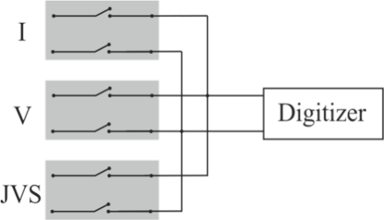 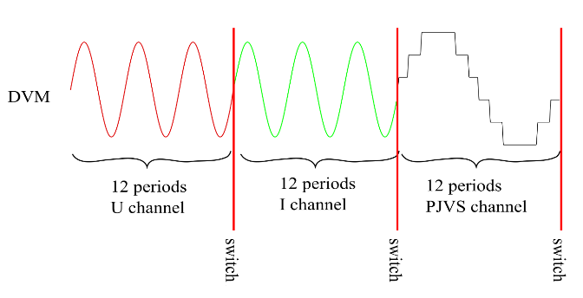

**Figure 1:** (left) Power measurement system and (right) signals measured by the digitizer. A digitizer measures the current, the voltage and the Josephson voltage in an alternating mode. Some periods of each signal are measured periodically and the PJVS can be adjusted to calibrate the corresponding range of the multimeter.

This multiplexer is designed to be flexible, the switching sequence and the trigger can be configured by a PC. In addition, it is built in a modular form, with a master board that controls slave boards and includes timing functionalities. The slave boards have a single pole and double throw (SPDT or 2-to-1), or a single pole and four throw (SPFT or 4-to-1). The user can use many of them controlled by the master, as the next figure shows.

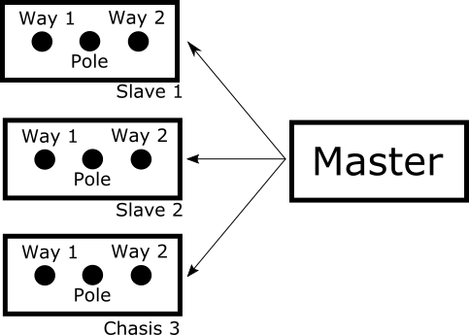

**Figure 2:** Three slave boards SPDT controlled by a single master board.

## Specification

The modular design of the multiplexer allows multiple configurations that can be selected by the users connecting the boards between them. The multiplexer uses the strategies break-before-make in order to avoid short circuits between sources and it switches synchronized with an external signal.

The signals are considered differential, so the switch commutes positive and negative terminals of the voltage source. Two slave boards have been designed, one has two throws and one pole, as the next figure shows, and the other has four throws and one pole. The slave board is reversible; the SPDT board can be considered as 2 inputs - 1 output (2-to-1) or 1 input - 2 output (1-to-2).

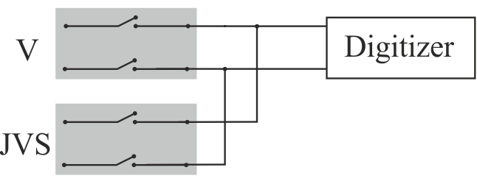

**Figure 3**: A slave board SPDT ready to measure a voltage source and the JVS.

Channel specification

* Maximum input voltage 60 V peak
* Turn on/off time: <3 ms
* Differential signal
* Coaxial connector for input and output signals
* Bounce-free operation
* Individual guard connection for each signals (binding post)
* Ground connection for the multiplexer
* Reversible operation

General specification

* Trigger input (BNC connector, opto-isolated)
* USB connection to PC for configuration and control
* 9 V DC External supply

Uncertainty contribution

* 0.5 Ω On-resistance
* Off-isolation at 1 MHz < -90 dB
* Crosstalk at 1 MHz < -100 dB
* Uncertainty contribution < 0.2 ppm at power line frequency
* Maximum uncertainty due to multiplexer: 1 ppm at 1 kHz.

# Theory of operation

## Slave board

Each switch is built in T-configuration using three solid-state relays to improve the overall off-isolation. The next figure shows a simple scheme in the blue box, S1 is connected to the voltage source and its output is connected with two relays. S3 connects the signal path to ground and S2 connects the signal path to the output. In the circuit schematic, the relays U3 - U7 are the signal relay for the high terminal and the U4 - U8 for the low terminal. The relays U5 and U6 are used to tie to ground the middle point, the ground is floating and can be connected to the source ground. The capacitances and resistor networks are used to improve transition time and reduced charge injection.

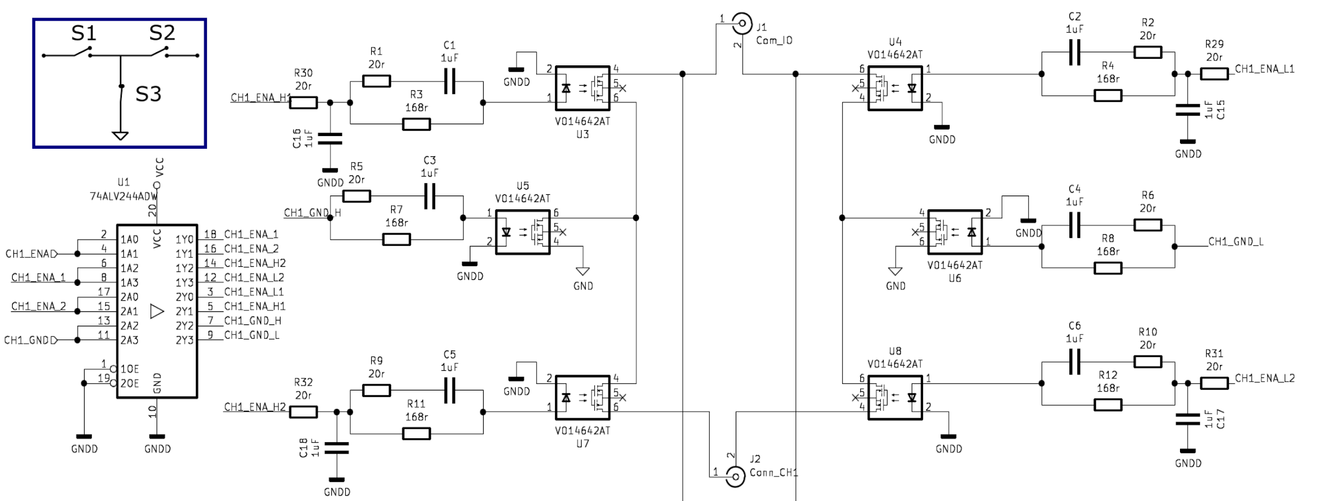

**Figure 4:** Circuit schematics for one differential channel, the switches are connected for each polarity in T configuration as the blue box shows.

The circuit board has a coaxial design, minimizing inductance path and stray capacitance. The figure 5 shows the top and bottom side of the slave-board, on one side are the high terminal relays and the other side has the low terminal relays. Both sides are organized equally to minimize the area enclosed by the current path. Three guarding rings are used to reduce the stray capacitance between channels and output, they can be connected to the instrument's guards. Several test points were included to measure the digital signal, they are indicated in the top side.

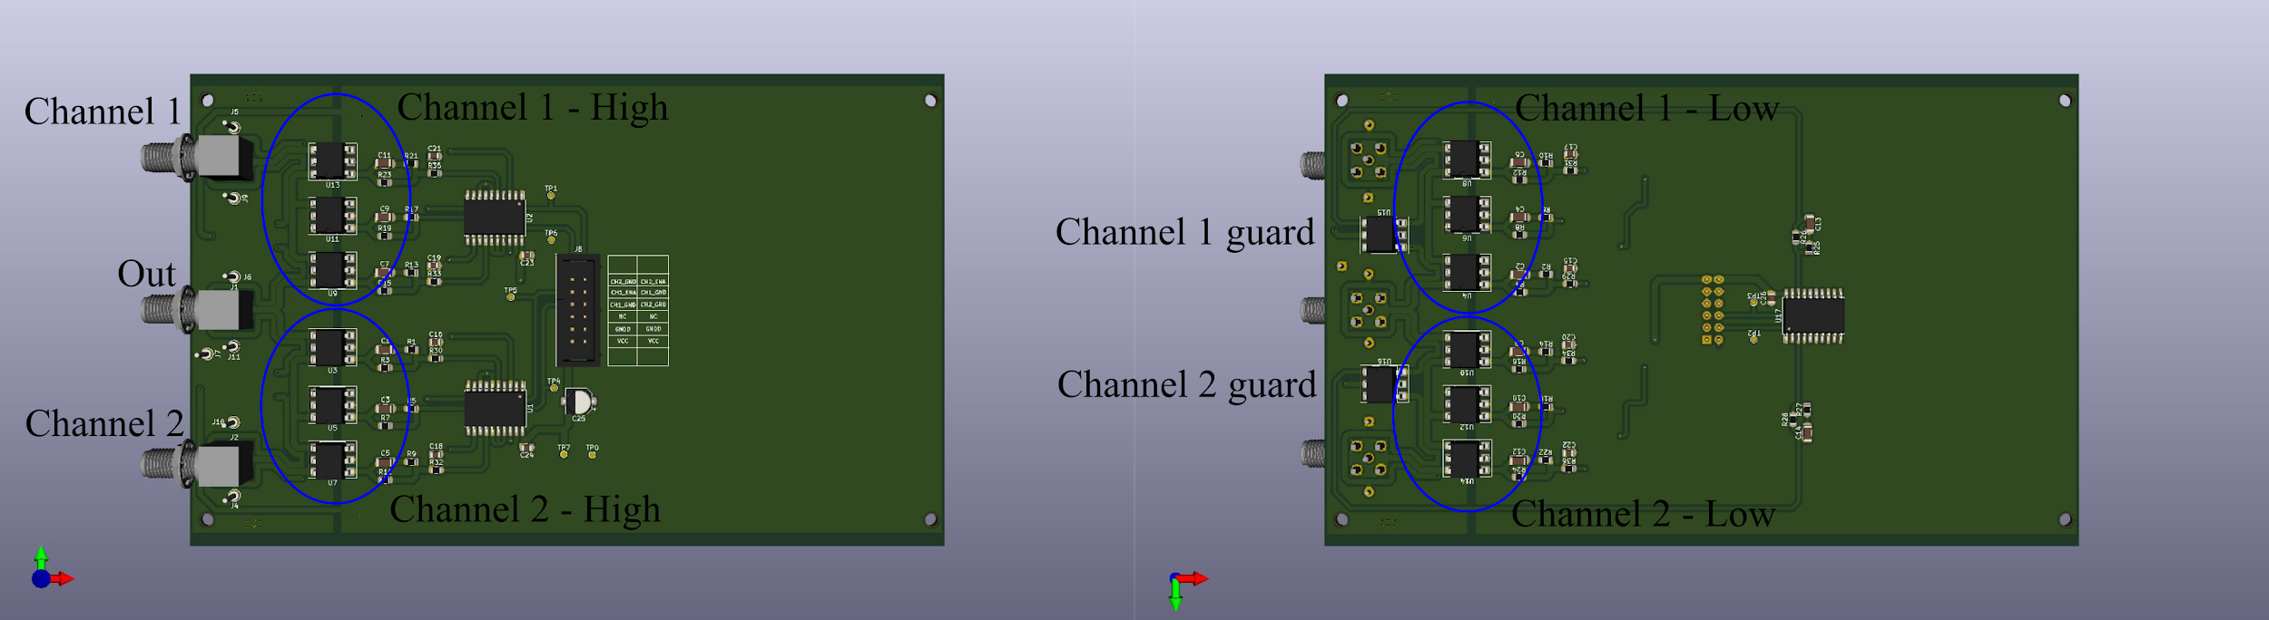

**Figure 5:** (left) Top and (right) bottom of the slave 2-to1 board.

During the open or close process, the activation of each relay must be done preventing a short circuit. A break-before-make strategy is implemented: first all switches are opened and then the correct configuration is set. A secure time is included to prevent a short circuit and will be set considering the relay specifications.

**Source of errors**

The multiplexer based on Solid-State relay has some source of error that were considered in the design and will introduce an uncertainty in the measurement system. The most important components are listed below.

On-resistance: The on-resistance *Ron* is the resistance of the conducting path of the relay and it builds a voltage divider with the load resistance *RL*. Thus, the measured voltage is affected by a systematic error, that can be calculated relative to input voltage as *Error = Ron/ (Ron +RL).*

In addition, leakage current due to finite impedance to ground can flow for this resistance increasing the error or introducing distortion. In order to reduce the effects of the on-resistance a relay with very low channel resistance and large impedance to ground was selected by mean of simulations.

Offset voltage: the relay presents some thermoelectric voltages in series with the conduction channel, which introduce some low-frequency noise. For the tested semiconductor relay, this voltage is negligible due to its small temperature gradients inside the device. In addition, the selected device due not present dependence between the voltage offset with the activation circuit.

Off-isolation and crosstalk: Both characteristics describe the effects of the input voltage on a channel in off-state to its output voltage (off-isolation) or to the output of a neighborhood channels (crosstalk). This can introduce distortion on the output signal that increase with the number of channels. The design of the multiplexer includes guard ring to improve isolation between channels and a symmetric design of the High and Low path to reduce the overall magnetic field pick up. In order to increase the off-isolation, a T configuration of the relay was used.

**Guard connection**

The slave board has switches to connect the guard of each throw with the guard of the pole, and the connectors are surrounded by a ring at guard potential. The figure shows the example to the slave board SPDT.

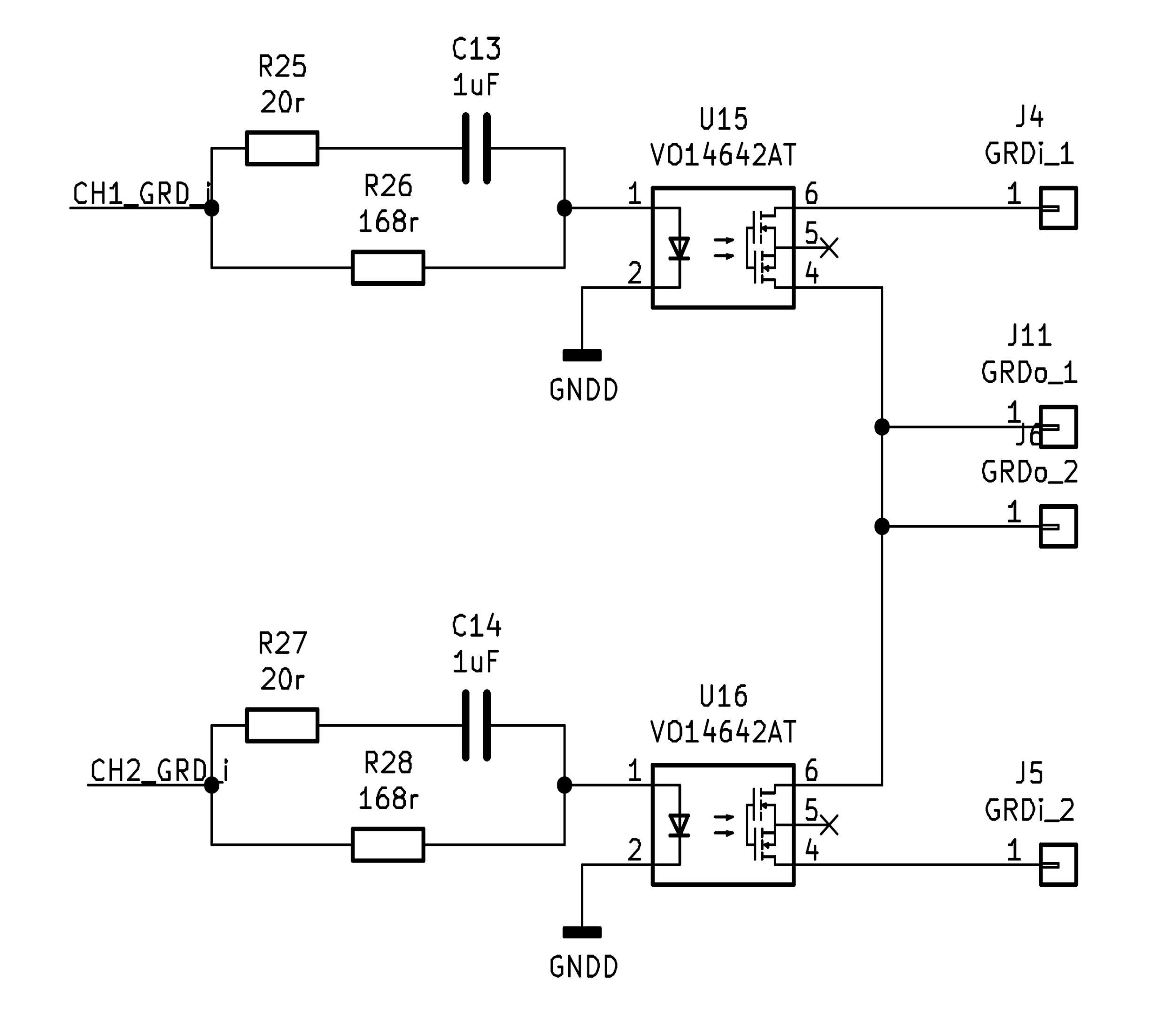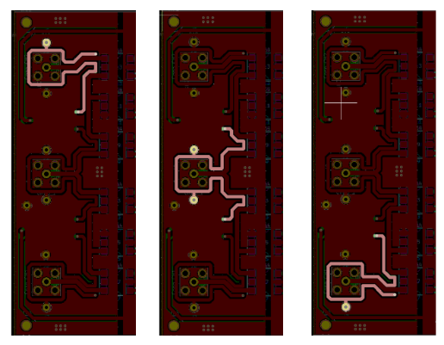

**Figure 6:** (left) Schematic circuit of the guard relays of the salve board SPDT. (right) guard rings on each connector.

**PhotoMos relay**

The following table shows the characteristic of the relay used on the first prototype. It was selected comparing by simulations elements from different manufacturer, and we found that this element has a balanced specification and it is available to buy.

**Table 1:** PhotoMos relay VO14642AABTR specification.

|  |  |
| --- | --- |
|  | **VO14642AABTR** |
| **ON-Resistance** | 0.18 Ω (AC) |
| **Max. voltage** | 60 V |
| **On-time** | 370 μs / 800 μs |
| **Off-time** | 50 μs / 800 μs |
| **Stray capacitance** | 200 pF |
| **Control current** | 0.5 mA to 20 mA |
| **Family** | Vishay |

In the case that the application requires another specification on the relay, the market offers a large number of compatible devices with different capabilities. The following table shows some equivalents elements with its mains characteristic obtained from specifications.

**Table 2:** PhotoMos relay models and main characteristics.

|  |  |
| --- | --- |
| **Relay** | **Main characteristics** |
| **PVT2125SPbf** | 150 V input voltage |
| **ASSR-1511-301E** | Low stray capacitance |
| **PVN012APbF** | Low on-resistance |

## Firmware and Flow chart

**Switching sequence matrix**

The switching sequence is transferred to the multiplexer by USB port and internally stored for further uses. The switching sequence can be considered as a matrix where each row represents the state of all the slave boards. The transition between each row will be controlled by a switching event. The user can configure the row value and in practice no more than 32 rows will be necessary. For example, if 3 slave boards are connected in a 4-step process, the matrix is:

**Table 3:** Binary switching sequence matrix for SPDT slave boards.

|  |  |  |  |  |  |  |  |
| --- | --- | --- | --- | --- | --- | --- | --- |
| **Step** | **Slave 1**  **Ch1** | **Slave 1 Ch2** | **Slave 2**  **Ch1** | **Slave 2 Ch2** | **Slave 3**  **Ch1** | **Slave 3 Ch2** | **Delay time (number of external trigger)** |
| **1** | 1 | 0 | 1 | 0 | 1 | 0 | 10 |
| **2** | 0 | 1 | 0 | 1 | 0 | 1 | 15 |
| **3** | 0 | 1 | 0 | 1 | 0 | 1 | 15 |
| **4** | 1 | 0 | 1 | 0 | 1 | 0 | 10 |

In the binary matrix one bit indicates the state of one channel, 0 indicates open and 1 indicates close. The matrix can be built with two bytes for channel states, so a total of 16 switches can be controlled, plus an extra byte to the numbers of clocks.

**Byte 1:**

|  |  |  |  |  |  |  |  |
| --- | --- | --- | --- | --- | --- | --- | --- |
| S4-CH2 | S4-CH1 | S3-CH2 | S3-CH1 | S2-CH2 | S2-CH1 | S1-CH2 | S1-CH1 |

**Byte 2:**

|  |  |  |  |  |  |  |  |
| --- | --- | --- | --- | --- | --- | --- | --- |
|  |  |  |  | S6-CH2 | S6-CH1 | S5-CH2 | S5-CH1 |

**Byte 3:** numbers of external trigger from 0 to 255

**Remote operation**

A trigger tree is considered to control the switching sequence, first the master board is armed and then, the state of the multiplexer channels change synchronized with the switching event. The arm and disarm message is provided by the PC. The switching event is defined as a trigger signal at trigger BNC plus a delay time based on integer numbers of trigger pulses. The following figure presents the trigger tree.

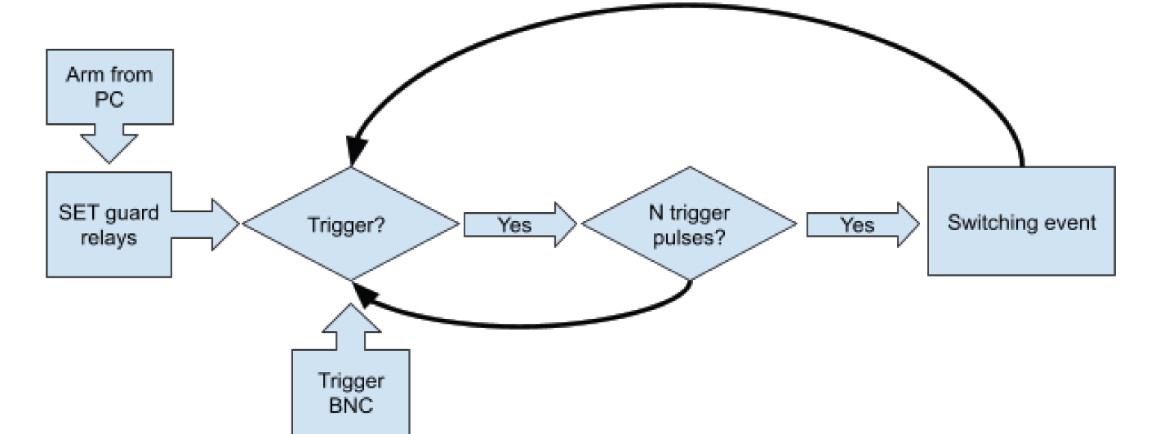

**Figure 7:** Trigger tree, the Arm message is provided by PC and “N” is the number of

external trigger pulses configured for each row in the matrix sequence.

**Switching pseudocode**

The following sequence gives information about the switching procedure, for more information go to Annex 4.

1. The PC configures the multiplexer and loads the switching matrix.
2. The PC arm the multiplexer.
3. The switches that connect the source guard are activated and they are not modified during the sequence.
4. The controller detects a trigger signal, the user can select positive or negative slopes.
5. The controller counts the numbers of pulses. When the configured value is reached the switching event is produced.
6. The controller writes FALSE on the “Ready for Trigger” bit.
7. Switching event (see figure 9):
   1. All the channels are opened. (Signal relays are opened, GND relay are closed).
   2. The GND relays of the ON channels are turned off.
   3. An enable delay time is implemented to prevent a short circuit. The secure time is 2 times the turn-off time of the relay.
   4. The corresponding signal relays are configured based on the corresponding row of the sequence matrix.
   5. The switch remains in the actual state during the delay configured.
   6. A counter to indicate the following matrix row is incremented.
8. The controller returns to point 4 and writes TRUE on the “Ready for Trigger” bit.
9. If a disarm command is received the controller returns to configuration state.

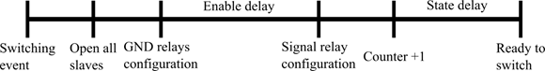

**Figure 8:** Time diagram of the operations after switching event, items 7a to 7f. The Enable delay must be larger than the maximum turn-off time of the relay.

**Local operation**

The multiplexer can be configured on local operation. The button “ENA CH” runs the sequence step by step, each time that the user pushes the button the multiplexer changes the state following the sequence matrix, which must be previously loaded, or the default sequence will be used.

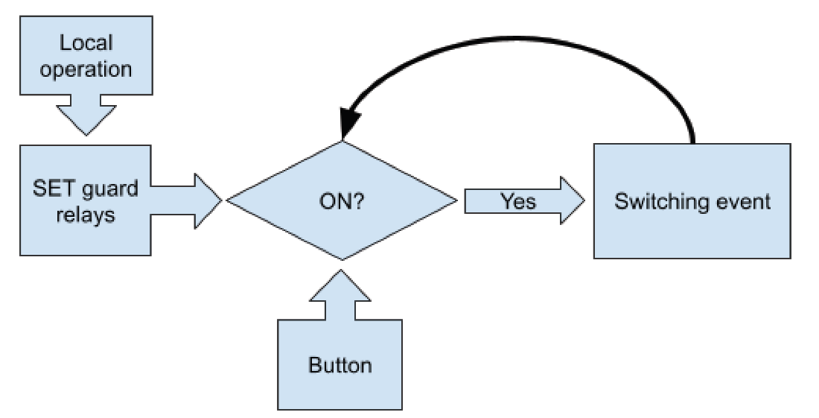

**Figure 9:** In local operation, the multiplexer changes between states with the ENA CH button.

# 

# Installation and connections

All the boards are designed to be fixed in a standard 19” case with a height of 3U (127 mm). The following figure shows one possible configuration with three SPDT slaves boards.

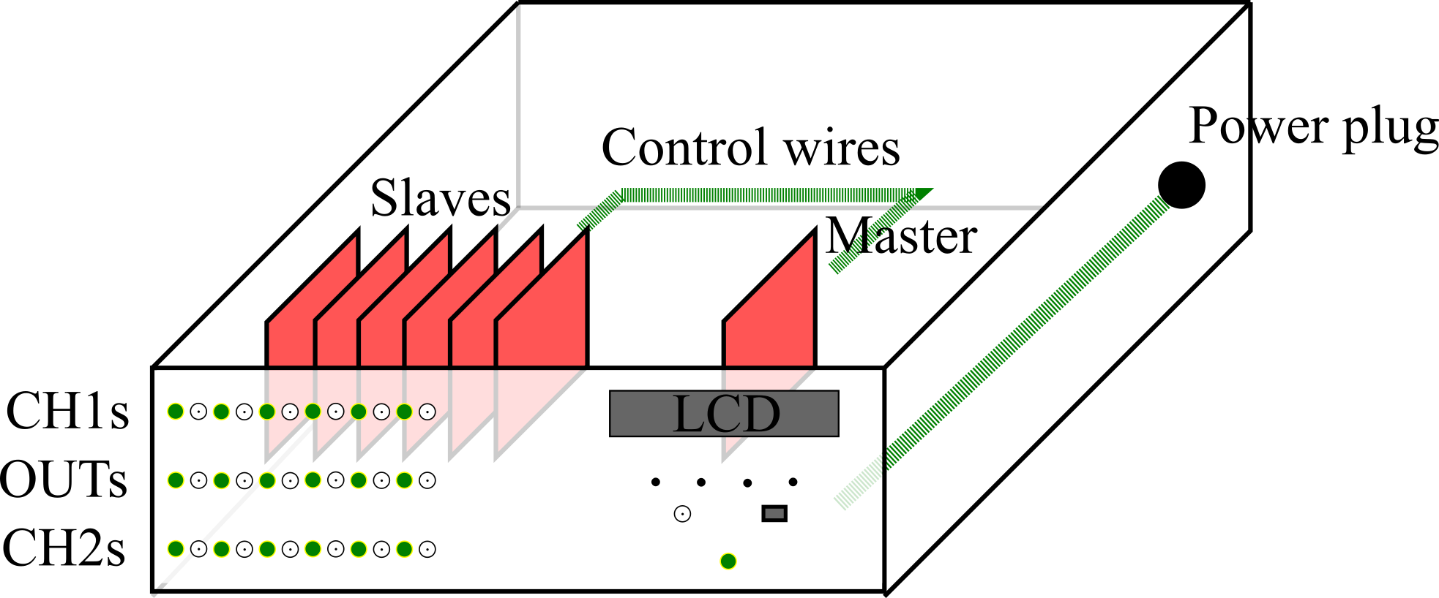

**Figure 10:** Recommended configuration of the case for SPDT slave boards.

Each slave can be connected to the front panel by means of coaxial wire for signals and unipolar wire for guard and ground. The guard voltage provides a shield ring around the inputs and the outputs, they help to reduce the stray capacitance between signals. The ground voltage is connected to the middle point of the T-configuration during turn-off state. In order to obtain high off-isolation, the ground terminal must be the source GND and it must be connected by means of a low impedance wire.

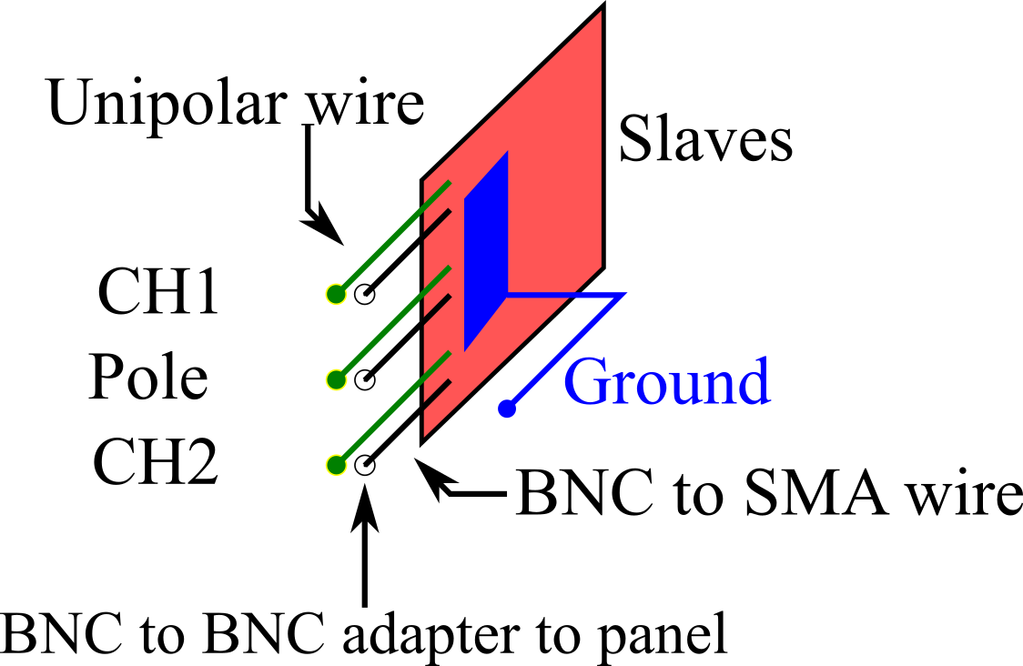

**Figure 11:** Connection diagram of the SPDT slave board.

The following figures show possible connections for the 2-to-1 board and the 4-to-1 board, and for different cases: 1, 2 and 3 multimeters. We also include the connection for the DC voltage measurement by differential method with the JVS. In all the cases, the diagram shows all the allowed slaves boards and the shadow BNCs are not used in that connection.

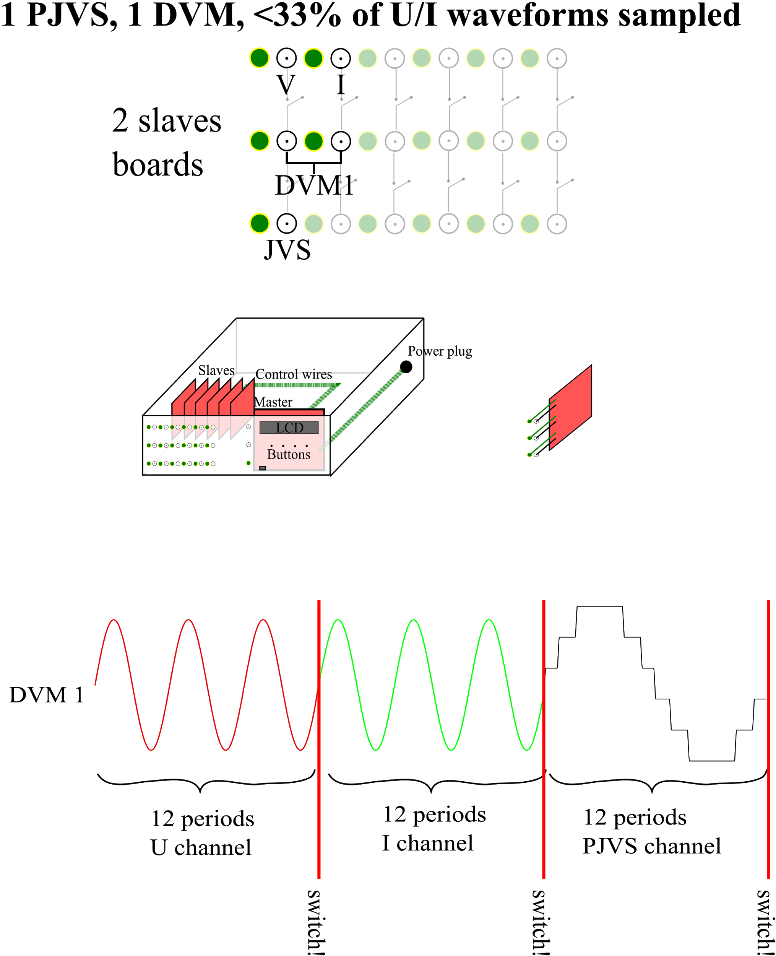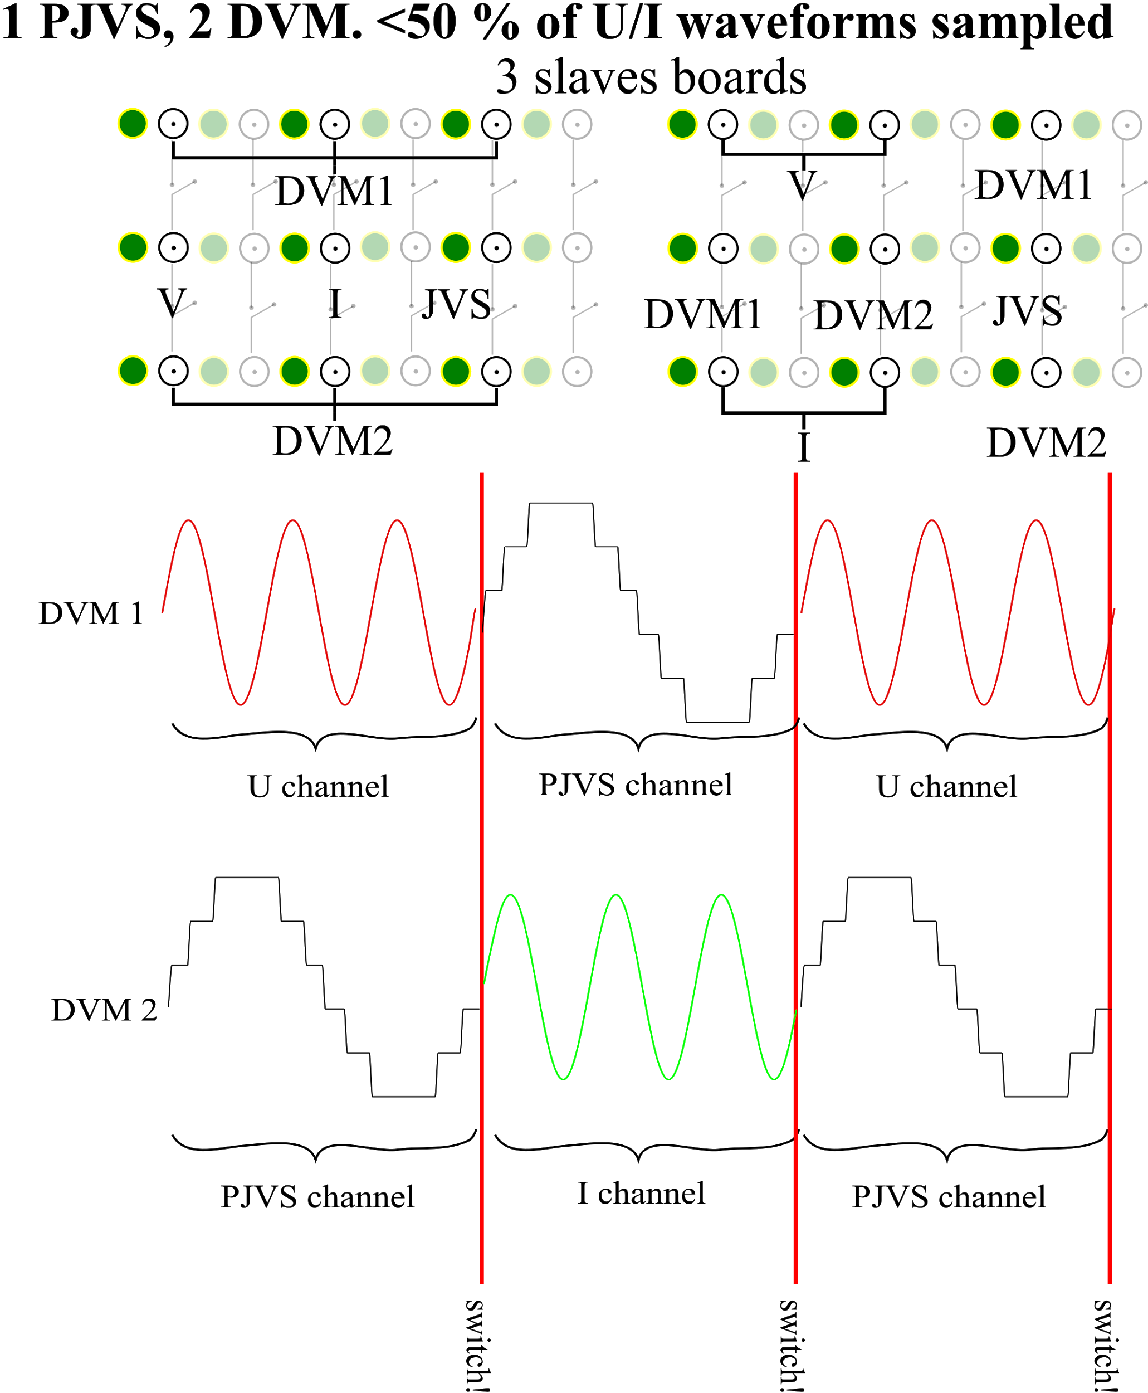

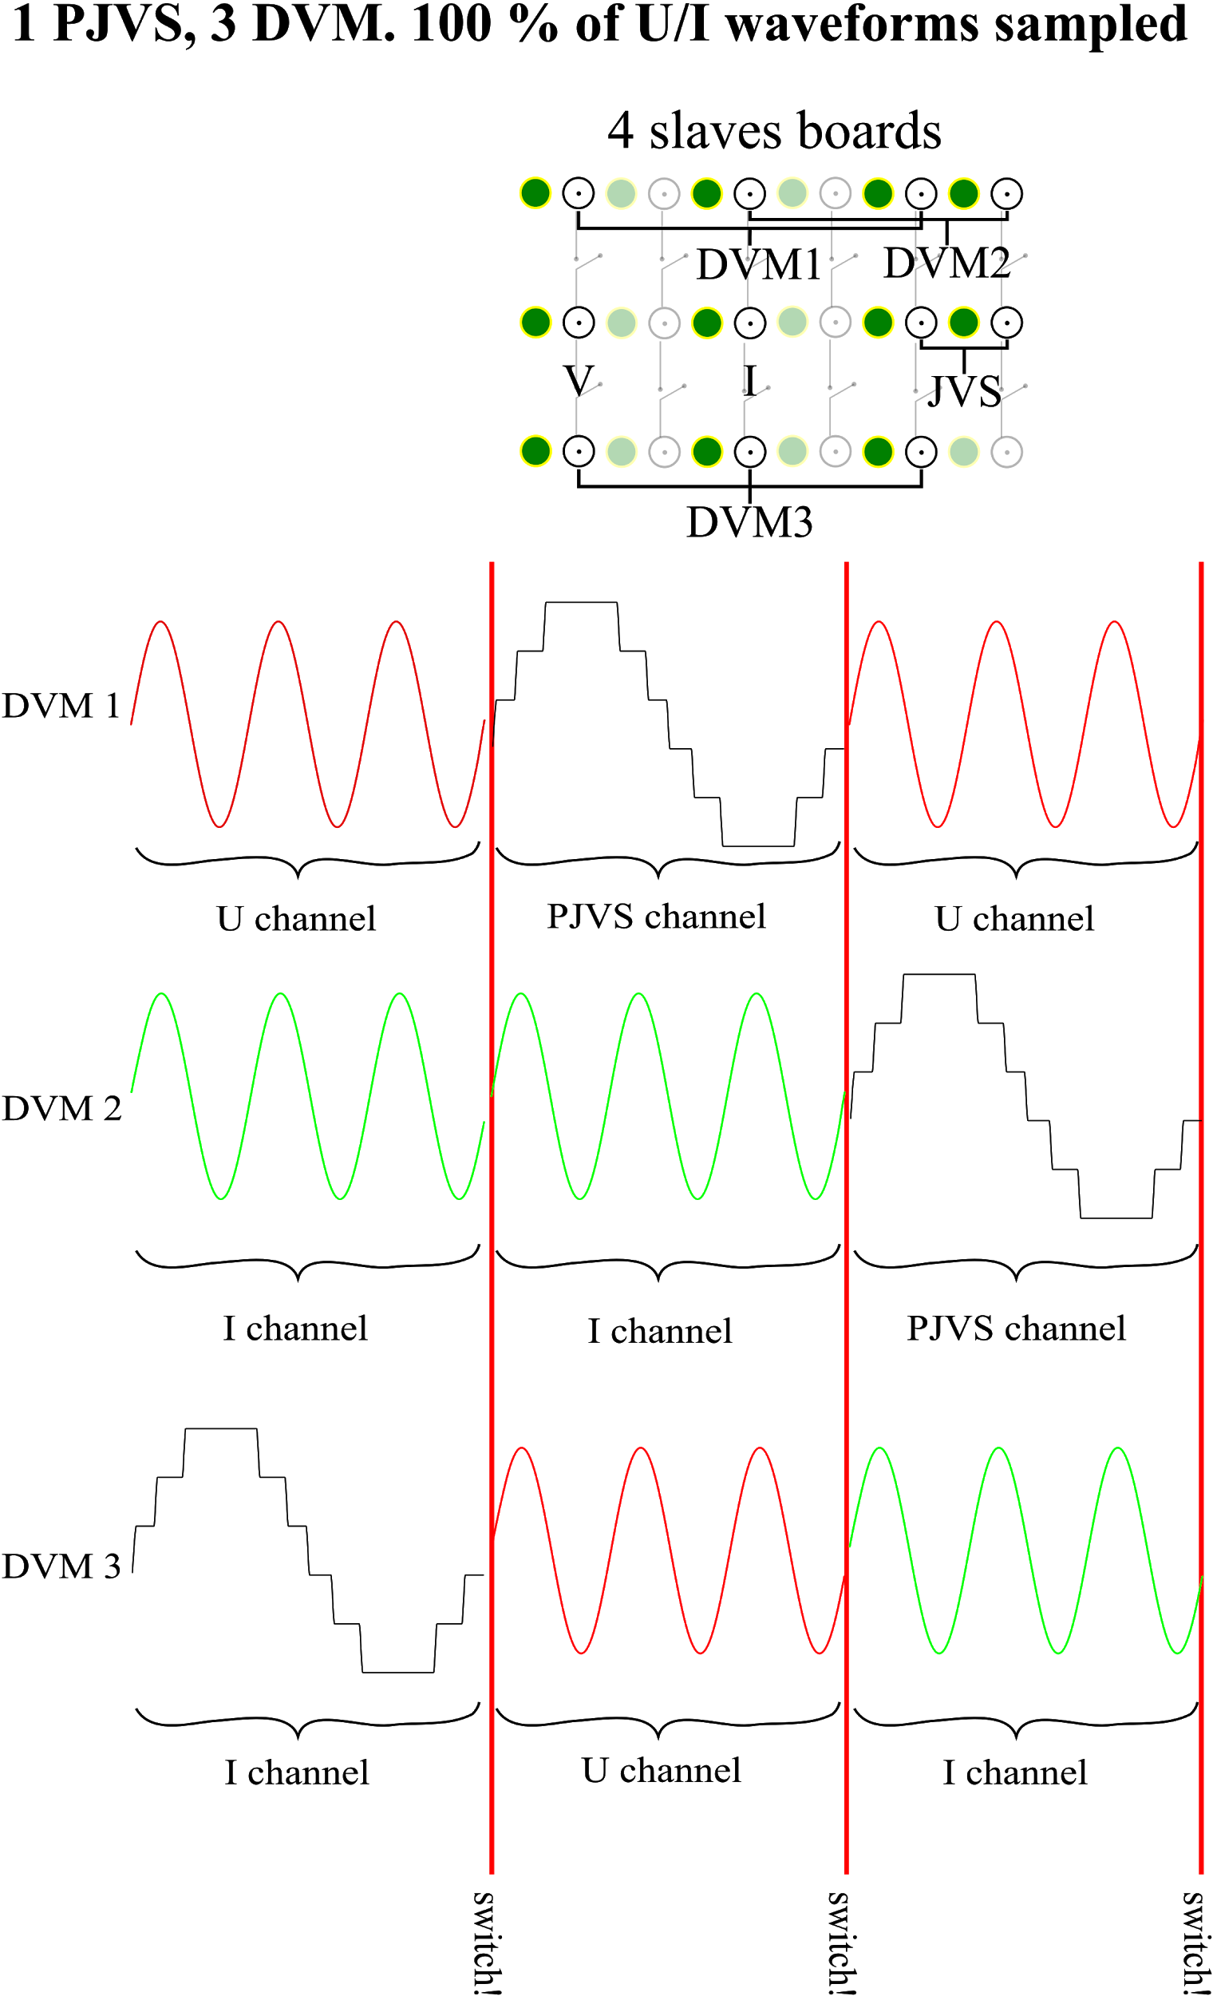 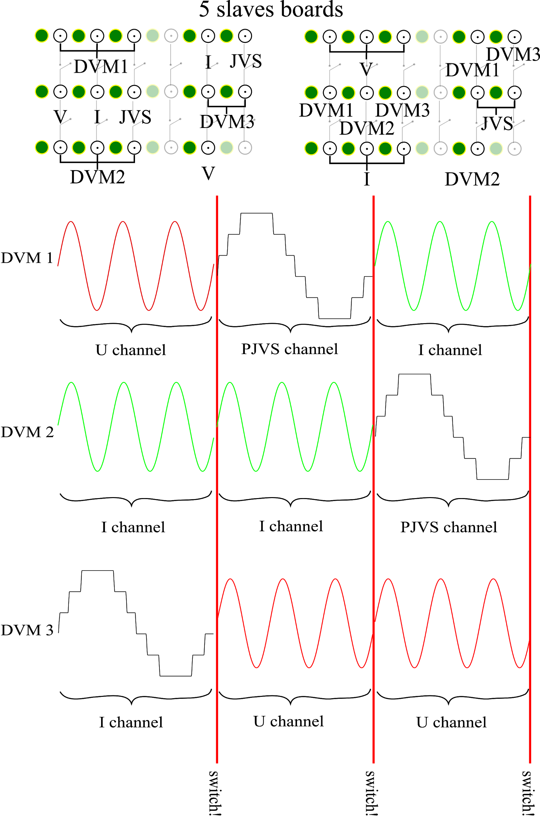

**Figure 12:** Connection diagram for 1, 2 and 3 multimeter for SPDT (2-to-1) slaves board.

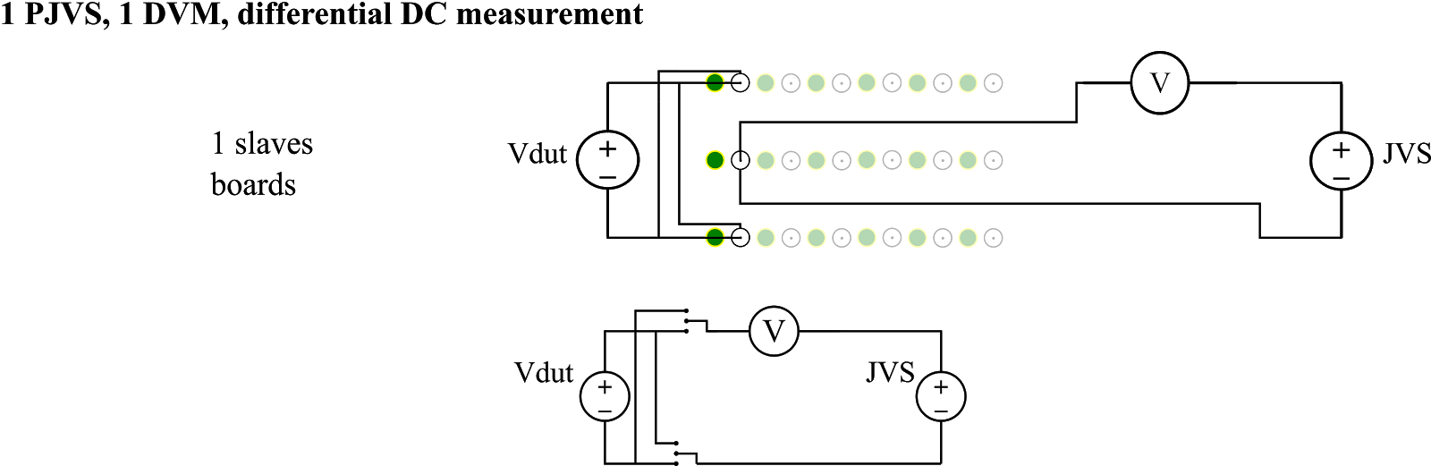

**Figure 13:** Connection diagram for DC measurement with SPDT slave board

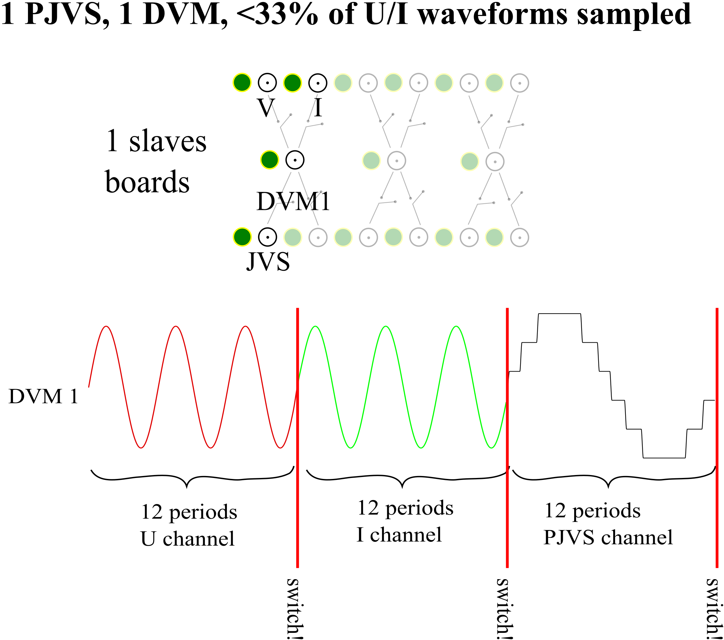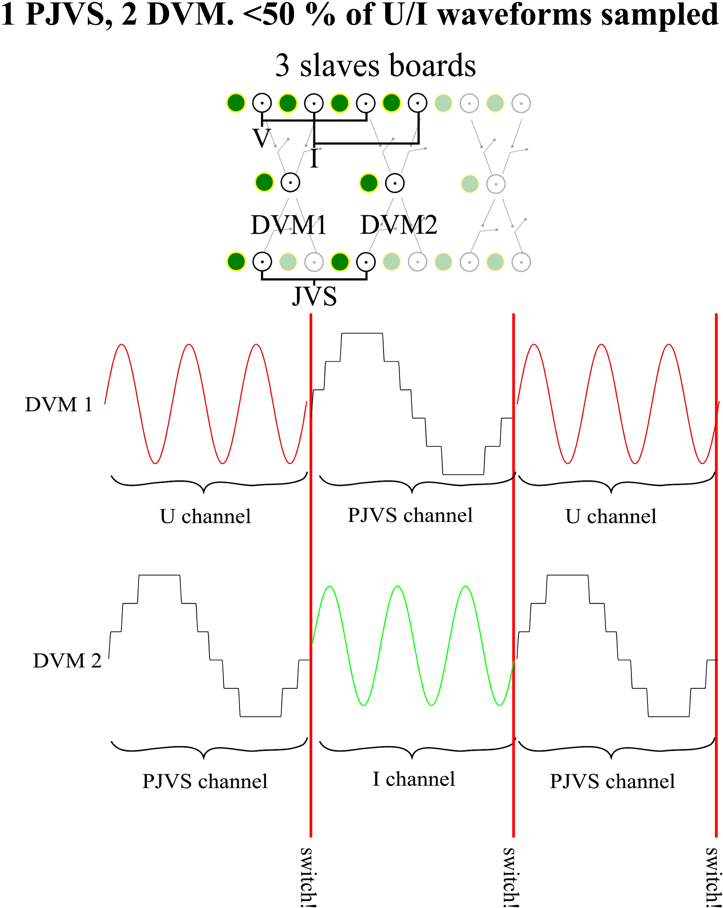

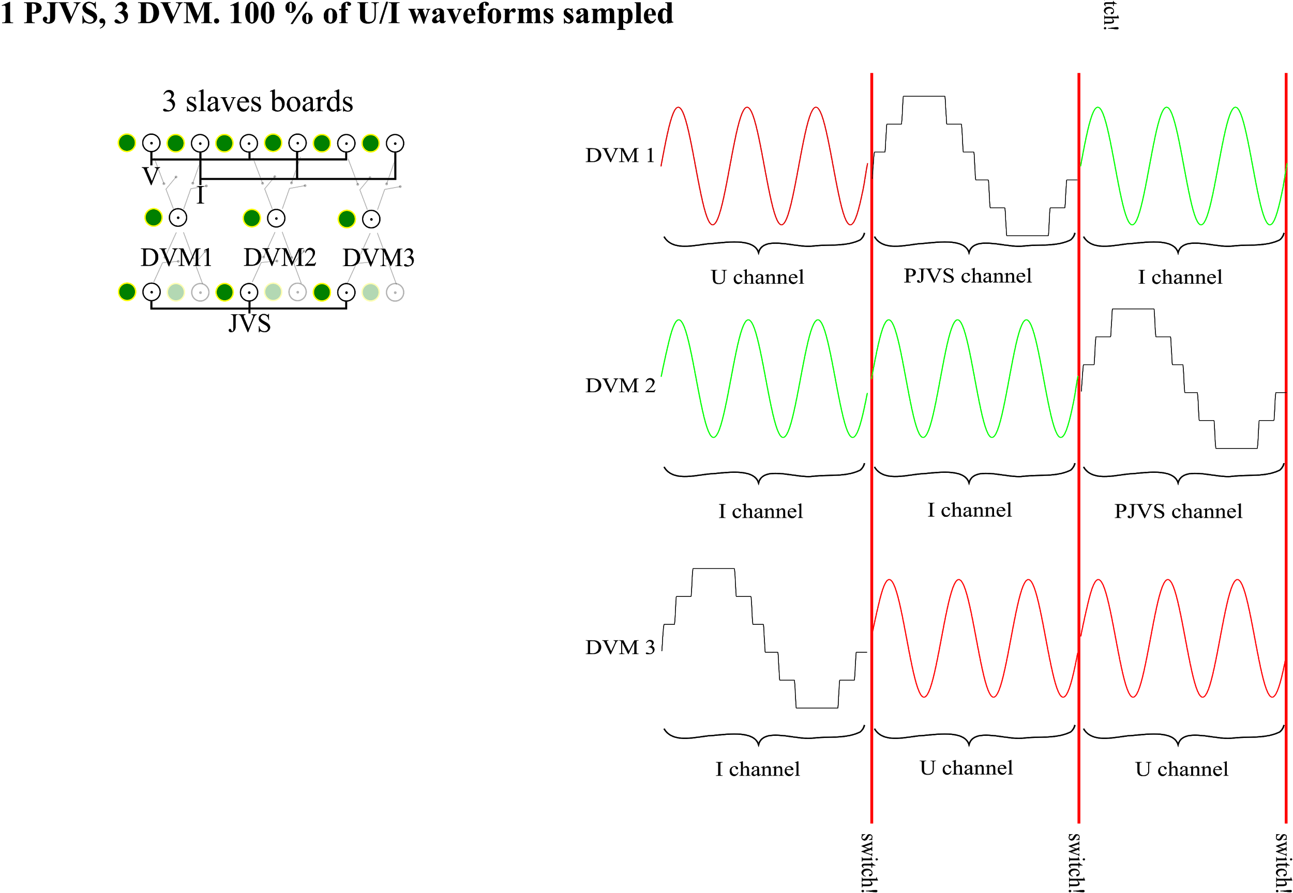

**Figure 14:** Connection diagram for 1, 2 and 3 multimeter for SPFT (4-to-1) slaves board.

# LabVIEW driver

## About

For implementation of the multiplexer into already developed software (TWM), a LabVIEW driver have been made. The driver can be accessed here:

<https://github.com/KaeroDot/QPsw/tree/main/QuPMX/QuPMXLabVIEWdriver>

## Driver structure

Driver is made in typical Initialize-Use-Close method. VIs for configuration and setup have been created according commands implemented in the firmware of the multiplexer.

The VI Tree is shown in figure 16.

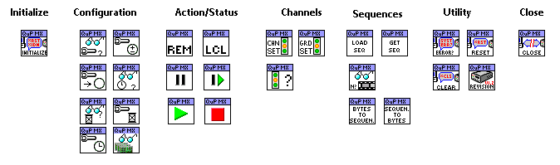

**Figure 15:** Overview of subprograms (VI) of the multiplexer driver.

## Multiplexer Control software and Driver Example

As an example, for use of the driver, a multiplexer control software *QuP Multiplexer Control* have been developed. The control software gives ability to manually control the multiplexer and set and read properties. The graphical user interface is shown in figure 17.

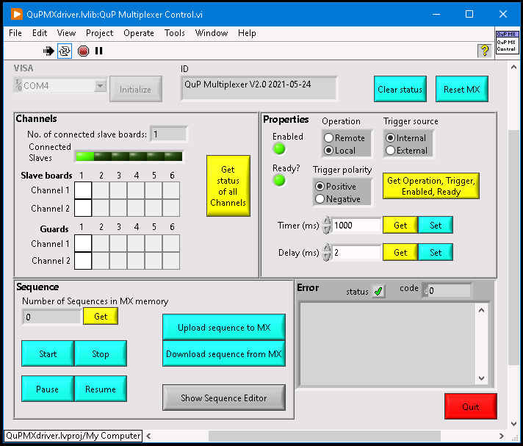

**Figure 16:** Graphical user interface of *QuP Multiplexer Control*.

The connection status of the slave boards can be changed by pressing appropriate buttons (white rectangles on the left side of graphical user interface).

The sequences that are to be loaded into multiplexer can be edited in the Sequence Editor (see figure 20) after pressing button *Show Sequence Editor*.

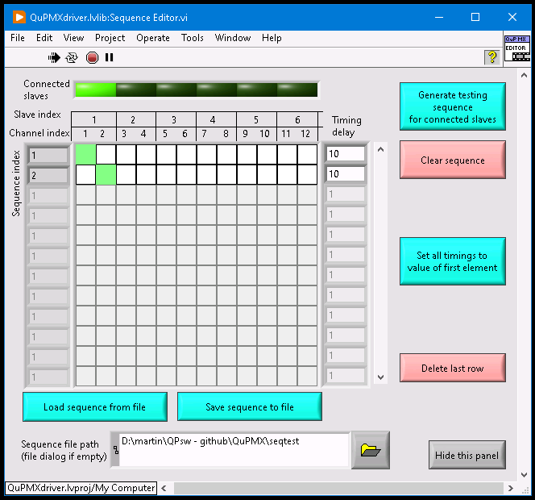

**Figure 17:** Graphical user interface of *QuP Multiplexer Control*, editor of sequences.

Any sequence can be manually created, loaded or saved from/to a file and uploaded or downloaded from/to multiplexer.

## Compiled binaries

The latest version of the compiled binaries of the driver library and control software can be accessed here:

<https://github.com/KaeroDot/QPsw/tree/main/QuPMX/QuPMXControl>

To run the control software, a run time libraries for LabVIEW 2020 are required.

# Measurements

## Multiplexer amplitude error

The amplitude error of the multiplexer was measured using PJVS and Fluke calibrator 5720A. The PJVS measured amplitude of the calibrator, and amplitude of the calibrator signal with multiplexer connected in between. See figure 21 for measurement setup.

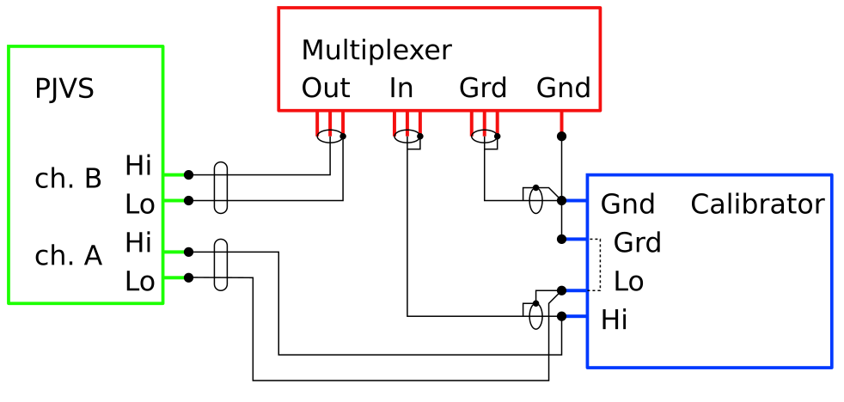

**Figure 18:** Measurement setup for multiplexer amplitude error estimation.

For every reading, the calibrator was set to 7 V at 1 kHz. First a calibrator voltage was measured by PJVS on channel A. Next the PJVS measured the signal on channel B. The error of the multiplexer was calculated as a difference of both measured values. This procedure was repeated.

The measured multiplexer error is (1.615 ± 2.383) µV for a 95 % level of confidence and 43 repetitions. That means the relative error is (0.231 ± 0.340) µV/V when referenced to the nominal source voltage of 7 V.

The figure 19 shows the measured values and figure 20 the Overlapped Allan deviation of the data. One can see the noise floor have not yet been reached and continued measurement would result in smaller uncertainty.

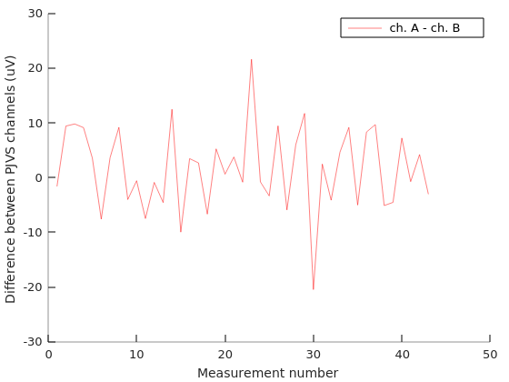

**Figure 19:** Difference between calibrator value measured directly and through multiplexer.

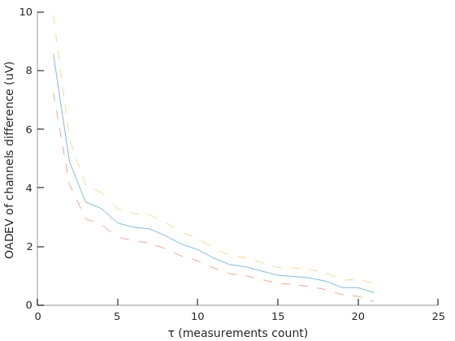

**Figure 20:** Overlapped Allan deviation of differences.

The uncertainty of the measurement is based only on type A uncertainty. Differential method of measurement was used in the PJVS. The type B uncertainties, such as PJVS digitizer errors should mostly cancel out by calculating difference between channels. The important type B uncertainty, that was not cancelled out, is the error of the inner multiplexer of the PJVS. This error was estimated by measuring calibrator output by both channels directly. The error was smaller than **0.39 µV**, unfortunately measured for insufficient number of repetitions.

The better method of measuring multiplexer offset would be measurement on single PJVS channel, with multiplexer switching during continuous sampling. This method will be possible after finishing whole measurement software to be developed in this project.

## Phase delay

### Setups

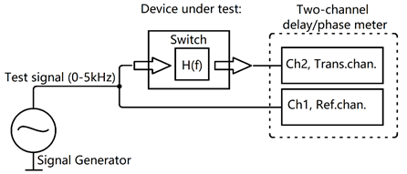

**Figure 21:** Setup for measuring phase delay through multiplexer.

* The delay/phase-meter consist of two 3458A, in a two-channel sampling setup.
* The device under test is the signal-path through the switch, Ch1-to-Out, and Ch2-to-Out separately.
* Signal-generator can either sweep a signal through 0-5 kHz, or generate a pink-noise, frequency-limited inside 0-5 kHz range.

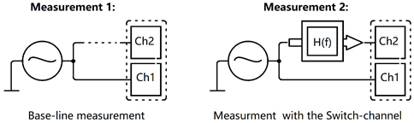

**Figure 22:** Base-line measurements to correct for the setup induces differences.

* For each channel of the switch, two measurements are done:
  1. A base-line measurement, to determine the contribution from the setup without the switch, and,
  2. Measurement when the signal go through the switch
* The delay/phase calculation is done by subtracting the base-line measurement from the switch-measurement.

### Results

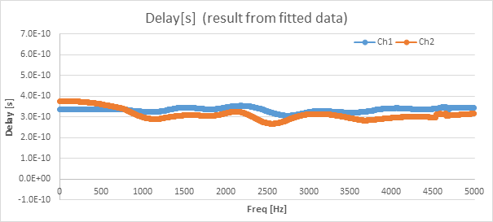

**Figure 23:** Delay measurements between the input and output of Ch1 and Ch2. The fitted data is an approximation to the local weighted average delay round the frequency.

The delay is flat over the tested frequency-range, within the uncertainty of the measurement. We see a little tendency that the delay of Ch1 is higher than Ch2, in the range of about 35 ps. The variations over the frequency-range is due to the noise. Better signal-to-noise can be achieved by longer measurements.

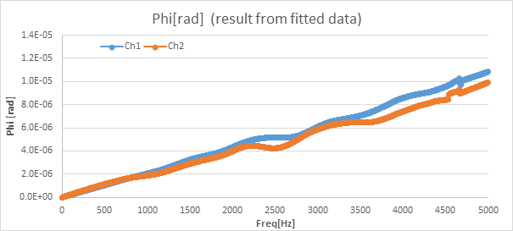

**Figure 24:** Phase difference between the input and output signal for Ch1 and Ch2. The fitted data is an approximation to the local weighted average delay round the frequency.

The phase is linear over the tested frequency-range, within the uncertainty of the measurement. We see a little tendency that the delay of Ch1 has a slightly higher phase-shift then Ch2. The variations over the frequency-range is due to the noise. Better signal-to-noise can be achieved by longer measurements.

**The measurement show that the added signal path through the switch contributes a delay of roughly 320 ps, and we found a difference of about 35 ps between the two channels. The value of the delays found, is within expected range, and can be interpreted as good for frequency-range of DC to 5 kHz.**

## Stray Capacitance

The stray capacitance of a turned-off PhotoMos was measured for several devices with a HP 4263A LCR bridge. The following table shows the results of series resistance and capacitance. The measurement where perform under four conditions with DC voltage applied with value equal to 0, 1.5 and 2 V. The AC voltage amplitude was 1 V or 0.1 V.

**Table 4:** measurements results of the stary capacitance for several PhotoMos.

|  |  |  |  |  |  |
| --- | --- | --- | --- | --- | --- |
| **Lote** |  | **1 VAC - 0 VDC** | **0.1 VAC - 0 VDC** | **0.1 VAC - 1.5 VDC** | **0.1 VAC - 2 VDC** |
| **V94368** | pF | 138 | 202.36 | 123.96 | 114.47 |
| kΩ | 2.3 | 1.093 | 1.6 | 2.9 |
| **V94368** | pF | 141.4 | 203.97 | 124.56 | 114.67 |
| kΩ | 2.3 | 1 | 1.8 | 2.689 |
| **V03768** | pF | 141.9 | 209.29 | 125.98 | 116.63 |
| kΩ | 10.7 | 7 | 2.85 | 2.9529 |
| **V03768** | pF | 142.22 | 205.39 | 125.25 | 115.69 |
| kΩ | 10.315 | 8.02 | 3.89 | 4.2029 |
| **V03768** | pF | 140.59 | 204.51 | 125.10 | 115.84 |
| kΩ | 11.02 | 8.13 | 3.7288 | 3.367 |
| **V03768** | pF | 133 | 194.30 | 122.08 | 113.40 |
| kΩ | 11.1 | 8.61 | 4.028 | 4.514 |
| **V03768** | pF | 139.2 | 204.79 | 124.67 | 115.62 |
| kΩ | 10.36 | 8.35 | 3.235 | 3.43 |

The stray capacitance introduces a leakage current with distortion due to the no-lineal characteristics of the measurements capacitance, the next figures shows the estimated model. This model was tested comparing the simulated leakage current with the measurements of the current leakage obtained with an oscilloscope and applying a 100 kHz signal to one device turned-off.

The current introduced by the PhotoMos turned-off can generate an error on the voltage applied on the digitizer by an activated channel. This error depends on the channel on-resistance and the source impedance, and simulations of the complete systems shows that the distortion is negligible for low impedance sources.

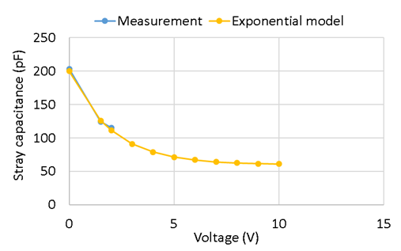

**Figure 25:** Comparison between measured and modeled stray-capacitance.

## Off-isolation and crosstalk

The off-isolation was measured introducing a sinusoidal signal of 1 MHz and 1 V at an input channel turned-off. The output is connected to a digital oscilloscope with the FFT activated to measure the same frequency component. All the set-up is couple at 50 Ω. The crosstalk is measured in the same way but the input channel is activated and the oscilloscope is connected other input channel. The measurement shows a ratio (output-input voltage) lower than –90 dB for the off-isolation and crosstalk. The procedure was repeated for input sinusoidal signal of 1 kHz obtained values lower than –120 dB, limited by the oscilloscope noise floor.

The isolation resistance was also measure at DC applying a fixed voltage to the turned-off channel and measuring the leakage current with a picoammeter. For a voltage of 10 V the output current was lower than 0.1 pA, so the isolation resistance was larger than 100 TΩ.

## On-resistance

The channel on-resistance was measured at the input terminal with a Kelvin connection and introducing a short circuit in the output. So, the series resistance of the high and low relay are evaluated, which includes four relay connected in series. The manufacturer specified a typically on-resistance of 0.18 Ω so the expected value was 0.72 Ω. However, the measured value was lower, 0.53 Ω.

# Annex 1. Analog circuit description

## Board connectors

**Table 5:** Slave board connectors.

|  |  |
| --- | --- |
| **Identification** | **Connector** |
| Control and supply | Ribbon Cable. PMOD interface. |
| Way 1, Way 2, Pole | SMA on board |
| Guard | Unipolar terminal |
| Ground | Unipolar terminal |

## Board digital pin-out

A 12-pin double-row connector (PMOD type) is used to connect the controller board and the relay board.

**Table 6:** Slave board digital lines.

|  |  |  |
| --- | --- | --- |
| **PIN** | **Name** | **Comment** |
| 1 | CH02_GND | Channel 2 ground connection |
| 2 | CH02_ENA | Channel 2 enable |
| 3 | CH01_ENA | Channel 1 enable |
| 4 | CH01_GRD | Channel 1 guard connection |
| 5 | CH01_GND | Channel 1 ground connection |
| 6 | CH02_GRD | Channel 2 guard connection |
| 7 | BD | Digital line tied to GND to indicate that the board is connected. |
| 8 | No connected | No connected |
| 9-10 | GND | Digital ground |
| 11-12 | Vcc | Digital voltage supply |

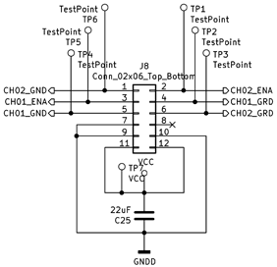

**Figure 26:** Schematic circuit of the digital connector.

## Test points list

**Table 7:** Test points on the SPDT slave board.

|  |  |
| --- | --- |
| **Test points** | **Signal** |
| 0 | GND Digital |
| 1 | CH02_ENA |
| 2 | CH01_GRD |
| 3 | CH02_GRD |
| 4 | CH02_GND |
| 5 | CH01_GND |
| 6 | CH01_ENA |
| 7 | VCC |

# Annex 2. Digital circuit description

## Master board

The master is built with an Arduino board and a shield board, this last one includes the connectors for 12 switches, and a voltage regulator to supply the slave boards. This voltage regulator is connected to an external supply of 12 V using a standard power connector Jack and Plug 2.1 mm x 5 mm. The Arduino-based board and the display are supplied by the USB connector. The used display is a 16x4 liquid crystal display (LCD) with I2C Communication.

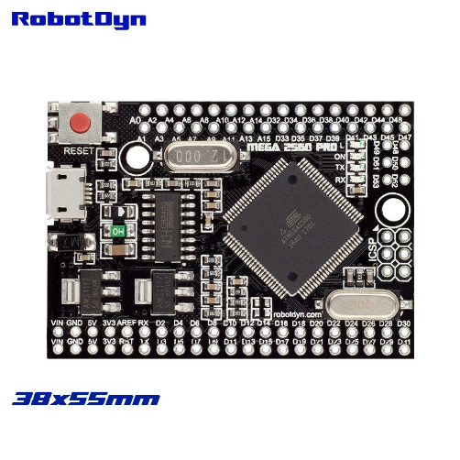

**Figure 27:** Arduino-based board manufactured by RobotDyn, <https://robotdyn.com/mega-2560-pro-embed-ch340g-atmega2560-16au.html>.

**Table 8:** Master board connectors.

|  |  |
| --- | --- |
| **Identification** | **Connector** |
| Control and supply for 6 slave control | Ribbon Cable. PMOD type. |
| Supply | Screw terminal |
| Clock IN | Opto-isolated BNC |
| Communication to PC | USB |
| Buttons control | 6 pinhead connector |
| Display control | 4 pinhead connector |

## Power-on state

1) All channels OPEN

2) All GRD OPEN

3) Local operation

4) Trigger Internal

5) Internal timer 2 s

6) No valid sequence in memory

## Serial configuration

Baud rate: 9600

Data Bits: 8 bits

Parity: None

Stop bit: 1 bit

Termination char: LF

Timeout: 10 s

Enable termination: FALSE

Flow control: none

## Driver for CH340 USB-Serial converter

Users of Windows PC must install a driver in order to have connection with the microcontroller by serial COM. The driver is available on the server in the directory: Multiplexer design / QPM design 2020 / Firmware / CH340_WinDRV.

In addition, the driver can be obtained from the board manufactured webpage <https://robotdyn.com/mega-2560-pro-embed-ch340g-atmega2560-16au.html>.

Or from the chip manufacturer:

<http://www.wch-ic.com/products/CH340.html>

<http://www.wch-ic.com/search?q=CH340&t=downloads>

## Push Buttons Description

The multiplexer has 4 push buttons:

**Table 9:** Master buttons.

|  |  |
| --- | --- |
| **Identification** | **Button** |
| RST | Reset the multiplexer as the *RST command does. |
| LOC/REM | This has two functions. Pressing it for more than 5 seconds change the state from REM to LOCAL operation or viceversa. Pressing it for less than 5 seconds shows on the last line in the display the sequence in memory in the form:  SEQ no.: byte 1 in hex | byte two in hex | byte three in hex.  For example:  1: 1 4 A => which corresponds to a sequence number 1 as: byte 1 = 1, byte 2 = 4, byte 3 = 10 in decimal |
| ENA CH | Runs the sequence in memory step-by-step. |
| μC RESET | This button reset the microcontroller, restarting it from power-on. |

## Timming diagrams

*t*ENA_ON: time to close a signal channel after an external trigger pulse

*t*DELAY = delay time

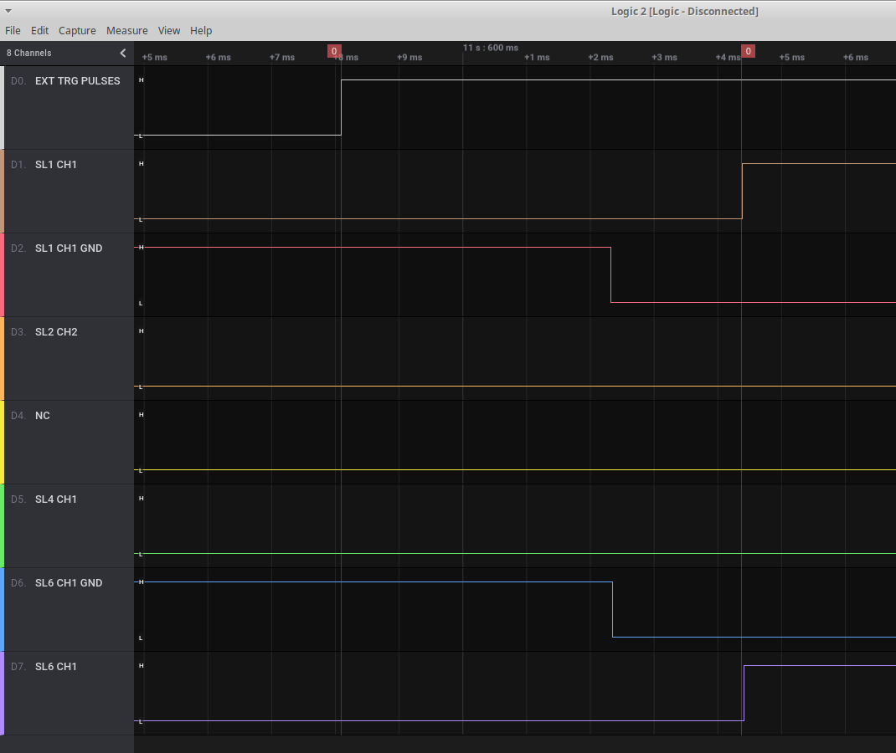**Figure 28:** Turn-on timing.

To estimate tENA_ON time use the following formula: *T*ena-on = (3 * *DELAY* + 0.225) ms

*DELAY* is the current DELAY time setting

*t*ENA_OFF: Time to wait until the channel is open

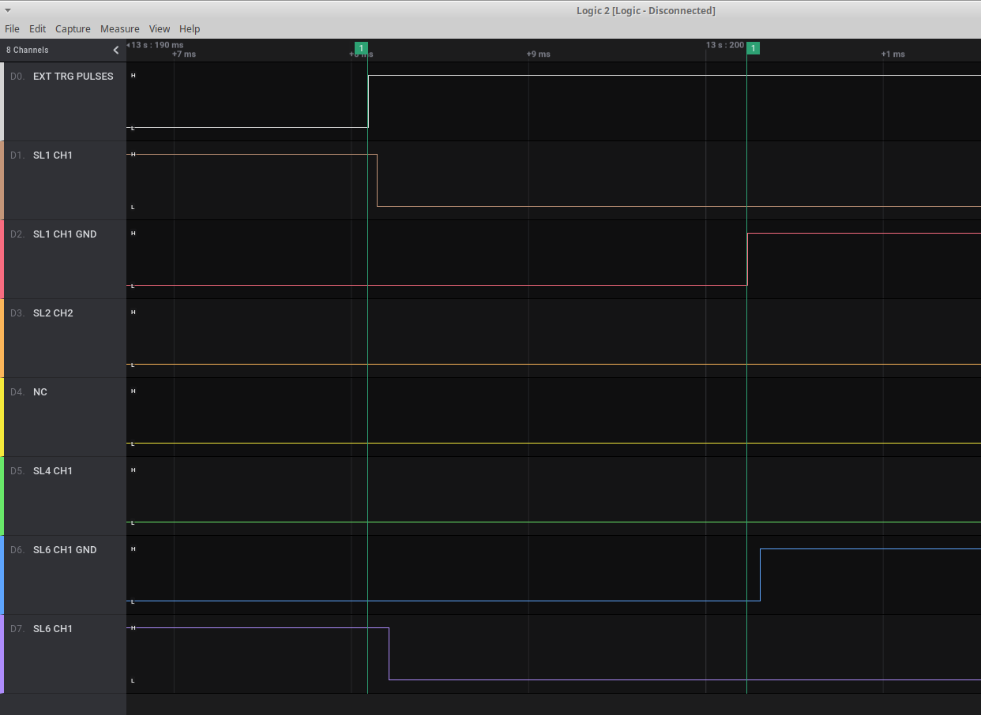**Figure 29:** Turn-off timing.

To estimate *t*ENA_OFF time use the following formula: *t*ENA-OFF = (*DELAY* + 0.125) ms



**Important**: ENABLE ON/OFF times also depends on the source and load impedance

# Annex 3. How to upload the firmware

Steps to upload the firmware to the microcontroller

**Method one**

1. Download and install de Arduino IDE environment from its web page (https://www.arduino.cc/en/software)
2. Open it.
3. Install the following external libraries:
   1. LiquidCrystal_I2C
   2. DebounceEvent
   3. CircularBufferLib
   4. SerialCommands

To do this step there are two ways install them using the IDE library manager or

copy the libraries which are provided in the ZIP file to the IDE library directory

1. Open the project “QuP_Multiplexer_V01” file. To do it go to File → Open menu.
2. Select the Board type under the Tools menu as “Arduino Mega or Mega 2560”.
3. Check that the selected serial COM port is the current port where the board is connected.
4. Finally compile and upload the firmware using the icon → arrow in the tool bar.

**Method two**

There is another method to upload the firmware without using the Arduino IDE. To do so use the provided python script “upload_.hex.py” and the .hex file “QuP_Multiplexer_V01.ino.mega.hex”.

1. Download and install the Arduino IDE as in method 1, because the application avrdude is needed.
2. Change the avrdude path according to your installation in the script line 10 and 11
3. Set the correct COM port where the board is plugged. Parameter -P line 15
4. run the python script.

If everything was Ok the script should upload the firmware to the microcontroller.

# Annex 4. Multiplexer command list

Date: May 2021

Firmware version 2.0

Authors: INTI

**Table 10:** Command list.

|  |  |  |  |
| --- | --- | --- | --- |
| **COMMAND** | **ARGUMENT #1** | **ARGUMENT #2** | **DESCRIPTION** |
| ENA | SLx CHx | ON | OFF | Enables channel x |
| STAT | SLx CHx |  | Returns channel status |
| *IDN? |  |  | Returns program ID |
| *RST |  |  | Resets the multiplexer. All the slaves are opened (signal relays turned OFF and GND relays turned ON). Guard relays turned OFF. Local mode. Internal trigger. Status byte to default value. |
| *CLS |  |  | Clears the multiplexer. All the slaves are opened (signal relays turned OFF and GND relays turned ON). Errors bits on status byte are cleared. |
| GTL |  |  | Go To Local operation |
| REM |  |  | Remote operation. Disables the front panel push buttons |
| TRG | INT | EXT |  | Trigger internal or external |
| TRGPOL | POS | NEG |  | Sets TRIGGER polarity |
| TIMER | < ms > |  | Sets the internal TIMER |
| TIMER? |  |  | Returns the internal TIMER in ms |
| START |  |  | ARM the multiplexer. Thus, it starts running the programmed sequence for each TRIGGER event. |
| STOP |  |  | Stops running the MUX |
| PAUSE |  |  | Pauses running the MUX |
| RESUME |  |  | Resumes the MUX after pausing it from the last sequence |

| **COMMAND** | **ARGUMENT #1** | **ARGUMENT #2** | **DESCRIPTION** |
| --- | --- | --- | --- |
| DELAY | <delay in ms> |  | Caution: decreasing this value can damage the multiplexer or the sources. An enable delay time is required to prevent short circuit when the signal relays are opened and the ground relays are closed or viceversa. This time depends on the relays and load. |
| DELAY? |  |  | Returns the current enable delay. |
| *STB? |  |  | Reports for the status byte |
| GRD | SLx CHx |  | ENABLE/DISABLE Guard at SLx CHx |
| ADDSEQ | SLx CHx W <no. trigger> |  | Adds a switching sequence |
| EDTSEQ | <seq> SLx CHx W <no. trigger> |  | Edits sequence number <seq> |
| LDSEQ | <no. of sequences to load> |  | Loads a sequence matrix into memory from PC (binary format) |
| STSEQ(*) |  |  | Saves the current sequence into the EEPROM |
| RLSEQ(*) |  |  | Recalls the last stored sequence from EEPROM to internal memory |
| GTSEQ(*) |  |  | Reports the current sequence from Memory to PC (binary format) |
| DELSEQ |  |  | Deletes last entered sequence |
| SEQ? | < no. > |  | Returns the sequence no. configuration |
| NSEQ? |  |  | Returns the total number of sequences in memory |
| NSLAVES? |  |  | Returns the number of slaves connected |
| WSLAVES? |  |  | Returns the slaves position in a byte as   |  |  |  |  |  |  |  |  | | --- | --- | --- | --- | --- | --- | --- | --- | |  |  | SL6 | SL5 | SL4 | SL3 | SL2 | SL1 | | B7 | B6 | B5 | B4 | B3 | B2 | B1 | B0 | | X | X | 0/1 | 0/1 | 0/1 | 0/1 | 0/1 | 0/1 |   The Bx is set if the slave is connected at the corresponding position. |

(*) NOT YET IMPLEMENTED!

Important: To start the multiplexer a valid sequence must be in memory. Then the trigger must be set to EXT.

**Example 1: Status byte**

To read the status byte use *STB?

**Table 11:** Status byte structure.

|  |  |  |  |  |  |  |  |
| --- | --- | --- | --- | --- | --- | --- | --- |
| **BIT 7** | **BIT 6** | **BIT 5** | **BIT 4** | **BIT 3** | **BIT 2** | **BIT 1** | **BIT 0** |
| LASTERR | | | RDY | MX_ENA | TRG POL | TRG INT /EXT | REM /LOC |
|  |  |  | /RDY=0  RDY=1 | ENA=0 DISA=1 | POS=0 NEG=1 | INT=0 EXT=1 | REM=0 LOC=1 |

**Table 12:** Status byte bit description.

|  |  |
| --- | --- |
| **BIT 0** | Is set to 0 when the MUX in on REMOTE operation.  Is set to 1 when the MUX is on LOCAL operation. |
| **BIT 1** | Is set to 0 when the trigger event is internal.  Is set to 1 when the trigger event is external. |
| **BIT 2** | Is set to 0 when the trigger polarity is positive.  Is set to 1 when the trigger polarity is negative. |
| **BIT 3** | Not yet implemented MX_ENA is always equal to 0, the multiplexer is on Enable state. |
| **BIT 4** | RDY, is set to 1 (RDY) when the MUX is on IDLE. Otherwise, is set to 0 (/RDY), indicating that a sequence is running. |
| **BIT 5**  **BIT 6**  **BIT 7** | See error codes table below |

**Table 13:** LASTERR: error codes.

|  |  |  |
| --- | --- | --- |
| Code number | Description | Condition |
| 0 (000) | No error | There is no error |
| 1 (001) | Command error | Indicates a wrong command |
| 2 (010) | Sequence error | Indicates 0 sequence in memory |
| 3 (011) | Sequence error | Indicates that the maximum number of sequences was reached |
| 4 (110) | ENA command error | Indicates that an error in ENA command |
| 5 (101) | SLV error | Indicates an error in ENA command when setting a SLAVE |
| 6 (110) | GRD error | Indicates an error in GRD command |
| 7 (111) | CH error | Indicates a channel error in the commands. |

**Example 2: to load a sequence matrix**

Use the command LDSEQ <number of states to be load>

The sequence will be loaded using three bytes for each state:

BYTE 1:

|  |  |  |  |  |  |  |  |
| --- | --- | --- | --- | --- | --- | --- | --- |
| **BIT 7** | **BIT 6** | **BIT 5** | **BIT 4** | **BIT 3** | **BIT 2** | **BIT 1** | **BIT 0** |
| SL4-CH2 | SL4-CH1 | SL3-CH2 | SL3-CH1 | SL2-CH2 | SL2-CH1 | SL1-CH2 | SL1-CH1 |

BYTE 2:

|  |  |  |  |  |  |  |  |
| --- | --- | --- | --- | --- | --- | --- | --- |
| **BIT 7** | **BIT 6** | **BIT 5** | **BIT 4** | **BIT 3** | **BIT 2** | **BIT 1** | **BIT 0** |
| X | X | X | X | SL6-CH2 | SL6-CH1 | SL5-CH2 | SL5-CH1 |

**BYTE 3**: a number between 1 to 255 indicating the number of trigger pulses to remain on the current sequence state.

Following you can see an example text file which can be uploaded using the VI or python script. The file can be generated by any text editor or by the VI module. The fields should be separated by TABs. Note that the byte 1 and 2 represents the states of the channels in binary format.

CH Byte 1 CH Byte 2 Delay Byte 3

1 4 10

10 0 10

4 0 1

8 0 1

16 0 1

32 0 1

64 0 1

128 0 1

0 1 1

0 2 2

0 4 2

0 8 2

0 4 2

0 2 4

0 1 5

1 0 4

64 0 1

10 0 1

**Figure 30:** Example of text file of the sequence matrix to be up load.

**Examples 3: configuring the scanner without sequence matrix**

ADDSEQ SL1 CH2 SL2 CH1 SL3 CH1 SL4 CH2 SL5 CH1 SL6 CH2 W 3→ Add a sequence to the multiplexer memory. The sequence is: close channel 2 (slave 1), channel 2 (slave 2), channel 1 (slave 3), channel 2 (slave 4), channel 1 (slave 5) and channel 2 (slave 6) and wait 3 trigger pulses to change to the next sequence.

ADDSEQ SL1 CH1 SL2 CH2 SL4 CH1 W 1 → Sequence: close channel 1 (slave 1), channel 2 (slave 2) and channel 1 (slave 4), then wait 1 pulse to the next sequence.

**Examples 4: useful commands**

***To enable a channel:***

ENA SL1 CH1 ON → close channel #1 of Slave #1

ENA SL2 CH2 OFF → open channel #2 of Slave #1

***To enable the guard relay:***

GRD SL1 CH2 ON → close the GRD of Slave 1 channel 2

GRD SL3 CH1 OFF → open GRD of slave 3 channel 1

***To set the internal timer:***

TIMER 160 → set the internal TIMER to 160 ms (the internal timer is for testing proposes)

To set internal or external trigger

TRG INT → Set the trigger mode to internal triggered

TRG EXT → Set the trigger to external

***To start the multiplexer:***

START → start running the MUX according to the sequence in memory.

***To ask for the number of slaves:***

NSLAVES? → Return msg: “TOTAL SLAVES: 2”

WSLAVES? → Return msg: XX000101

# Annex 5. Switching Firmware

This annex explains the algorithm used to switch between the multiplexer channels. First, the switching pseudocode and firmware are introduced from an overall point of view. Then, each step of the algorithm is deeply studied.

**Switching pseudocode and firmware**

1. The PC configures the multiplexer and loads the switching matrix.
2. The PC arm the multiplexer.
3. The switches that connect the source guard are activated and they are not modified during the sequence.

*Slave::CH_ENAGRD()*

1. The controller detects a trigger signal, the user can select positive or negative slopes.

*setTrigMode()*

*triggerChINT()*

1. The controller counts the numbers of pulses. When the configured value has reached, the switching event is produced.
2. The controller writes FALSE on the “Ready for Trigger” bit.
3. Switching event (see figure):

*void runSlaveSequence(void){*

*uint8_t nSlv = slavesList.Count();*

*if(TRGCounter == trgWait){*

*open_all_slaves(nSlv);*

*sequence.openGND(islaveSeq);*

*delay(MUX.getdly());*

*sequence.closeCH(islaveSeq);*

*trgWait = sequence.SeqBuffer[islaveSeq].byteThree;*

*islaveSeq++;*

*if (islaveSeq == sequence.getSeqSize())*

*islaveSeq = 0;*

*TRGCounter = 0; }*

*return;}*

a. The signal switches are opened, and the ground switches are closed.

f. A counter to indicate the following matrix row is incremented.

This condition defines the switching event (point 5).

b. The GND switches of the ON channels are turned off.

c. An enable delay time is implemented to prevent a short circuit. The secure time is 2 by the turn-off time of the relay.

d. The corresponding signal relays are configured based on the corresponding row of the sequence matrix.

e. The switch remains in the actual state during the delay configured.

1. The controller returns to point 4 and writes TRUE on the “Ready for Trigger” bit.
2. If a disarm command is received the controller returns to the configuration state.

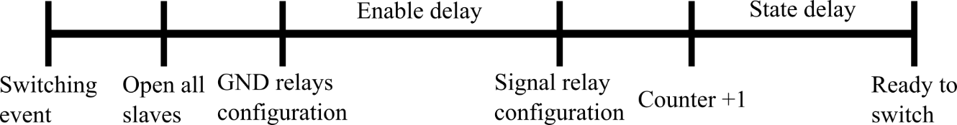

**Figure 31:** Time diagram of the operations after switching event, items 7 a to 7 f. The Enable delay must be larger than the maximum turn-off time of the relay.

##### Point 7.a

This function opens all the signal relays and closes the GND relay.

The connected slaves are saved on the list *slavesList[j].*

*//OPEN/CLOSE the corresponding signal relays*

*void Slave::CH_ENA(uint8_t iCH, state_t state)*

*{*

*uint8_t iPins;*

*switch (iCH){*

*case 1:*

*iPins = CH1iPin;*

*iState[1] = state; break;*

*case 2:*

*iPins = CH2iPin;*

*iState[2] = state; break;*

*}*

*digitalWrite(iPins, state);*

*return;}*

*void open_all_slaves(byte nSlaves)*

*{*

*int j=0;*

*//First OPEN all Signal Relays of all present slaves*

*for(j=0; j < nSlaves; j++){*

*pSlave = slavesList[j];*

*pSlave->CH_ENA(1, OFF);*

*pSlave->CH_ENA(2, OFF);*

*}*

An enable delay time is implemented to prevent a short circuit.

*delay(MUX.getdly());*

*//OPEN/CLOSE the corresponding GND relay*

*void Slave::CH_GND(uint8_t iCH, state_t state){*

*uint8_t gPins;*

*switch (iCH){*

*case 1:*

*gPins = CH1gPin; break;*

*case 2:*

*gPins = CH2gPin; break;*

*}*

*digitalWrite(gPins, state);*

*return; }*

*//The after the settle waiting time CLOSE ALL GND relays*

*for(j=0; j < nSlaves; j++){*

*pSlave = slavesList[j];*

*pSlave->CH_GND(1, ON);*

*pSlave->CH_GND(2, ON);*

*}*

*return;*

*}*

##### Point 7.b

This function opens the GND relays for the channels to be activated.

*bool Sequence::openGND(uint8_t SeqNo)*

*{*

*Slave *pSlave=NULL;*

*uint16_t Activate=0x0000;*

*byte Act=0x00;*

*//Set Activate variable for all slaves*

The first and second bytes are included in the same variable.

*Activate = SeqBuffer[SeqNo].byteTwo;*

*Activate <<= 8;*

*Activate |= SeqBuffer[SeqNo].byteOne;*

*//Here I have to parse and config the sequence to be run by the controller*

*for(int k=0; k < slavecnt; k++){*

The corresponding bits are obtained.

*pSlave = (*pslavesList)[k];*

*switch(pSlave->ID){*

*case 01:*

*Act = Activate & MASK_01; break;*

*case 02:*

*Act = (Activate>>2) & MASK_01; break;*

*case 03:*

*Act = (Activate>>4) & MASK_01; break;*

*case 04:*

*Act = (Activate>>6) & MASK_01; break;*

*case 05:*

*Act = (Activate>>8) & MASK_01; break;*

*case 06:*

*Act = (Activate>>10) & MASK_01; break;*

*default:*

*Serial.println("SEQ ERROR");*

*return false; }*

*switch (Act){*

If the channel bits indicate that a channel is close, the corresponding GND relay is opened.

*case 0b01:*

*//CH01*

*pSlave->CH_GND(1,OFF); break;*

*case 0b10:*

*//CH02*

*pSlave->CH_GND(2, OFF); break;*

*case 0b11:*

*//BOTH*

*pSlave->CH_GND(1, OFF);*

*pSlave->CH_GND(2, OFF); break;*

*default:*

If the bits are 00, the GND relays remain close.

*break; //NOT Valid }*

*}*

*return true;}*

##### Point 7.d

This function closes the signal relays for the activated channels.

*bool Sequence::closeCH(uint8_t SeqNo)*

*{*

*Slave *pSlave=NULL;*

*uint16_t Activate=0x0000;*

*byte Act=0x00;*

*//Set Activate variable for all slaves*

The first and second bytes are included in the same variable.

*Activate = SeqBuffer[SeqNo].byteTwo;*

*Activate <<= 8;*

*Activate |= SeqBuffer[SeqNo].byteOne;*

*//Here I have to parse and config the sequence to be run by the controller*

*for(int k=0; k < slavecnt; k++){*

The corresponding bits are obtained.

*pSlave = (*pslavesList)[k];*

*//Serial.println(pSlave->ID);*

*switch(pSlave->ID){*

*case 01:*

*Act = Activate & MASK_01; break;*

*case 02:*

*Act = (Activate>>2) & MASK_01; break;*

*case 03:*

*Act = (Activate>>4) & MASK_01; break;*

*case 04:*

*Act = (Activate>>6) & MASK_01; break;*

*case 05:*

*Act = (Activate>>8) & MASK_01; break;*

*case 06:*

*Act = (Activate>>10) & MASK_01; break;*

*default:*

*Serial.println("SEQ ERROR");*

*return false; }*

*switch (Act){*

*case 0b01:*

If the channel bits indicate that a channel is close, the corresponding SIGNAL relays are closed.

*//CH01*

*pSlave->CH_ENA(1, ON); break;*

*case 0b10:*

*//CH02*

*pSlave->CH_ENA(2, ON); break;*

*case 0b11:*

*//BOTH*

*pSlave->CH_ENA(1, ON);*

*pSlave->CH_ENA(2, ON); break;*

*default:*

*break; //NOT Valid }*

*}*

*return true;}*

# Annex 6. Master board

|  |  |  |  |
| --- | --- | --- | --- |
| **Item** | **Package** | **Designation** | **Vendor** |
| F1 | Fuse_Littelfuse-NANO2-451_453 | Fuse | Littelfuse Inc. - 015401.5DR |
| J5 | Molex_Mini-Fit_Jr_5566-04A_2x02_P4.20mm_Vertical | Conn_02x02_Top_Bottom | Molex - 39-28-1043 |
| D1 | D_SMB_Handsoldering | S2M | ON Semiconductor – S2M |
| J3 | PinSocket_2x03_P2.54mm_Vertical | Conn_02x03 | Sullins Connector Solutions – PPTC032LFBN-RC |
| J7 | PinSocket_1x06_P2.54mm_Vertical | Conn_PUSH_B | Würth Elektronik – 61300611121 |
| J7a option R/A | PinSocket_1x06_P2.54mm_Right Angle |  | Würth Elektronik – 61300611021 |
| Trigger_IN1 | SMA_Amphenol_132134_Vertical | Conn_Coaxial | Amphenol RF – 132134 |
| H4,H3,H2,H1 | MountingHole_3.2mm_M3 | MountingHole | ---- |
| U3 | SOT-223-3_TabPin2 | LM1117-5.0 | Texas Instruments – LM1117MP-5.0/NOPB |
| U1 | SMDIP-8_W9.53mm | HCPL-2400 | Broadcom - HCPL-2400-300E |
| S1, S2, S3, S4, S5, S6 | IDC-Header_2x06_P2.54mm_Vertical | Conn_Slaves | MOLEX - 90130-1112 |
| R1 | R_0805_2012Metric | 620 ohm | TE Connectivity – CPF0805B620RE |
| C12,C9 | CP_Elec_5x3 | 10uF | Panasonic - EEEHB1V100R |
| C1, C11 | C_0805_2012Metric | 100nF | KEMET – C0805C104K4RACTU |
| C10 | CP_Elec_5x3 | 47uF | Panasonic – EEEFT1V470AR |
| C2 | C_0805_2012Metric | 15p | KEMET – C0805C150J5GACTU |
| J1 | PinSocket_2x21_P2.54mm_Vertical | Conn_02x21=42 in two parts |  |
| J1A |  | conn 16pos 2 rows | Sullins Connector Solutions – PPTC082LFBN-RC |
| J1B |  | conn 32pos 2 rows | Sullins Connector Solutions - PPTC162LFBN-RC |
| J2 | PinSocket_2x16_P2.54mm_Vertical | Conn_02x16 | Sullins Connector Solutions – PPTC162LFBN-RC |
| J4 | PinHeader_1x04_P2.54mm_Vertical | Conn_DISPLAY_I2C | Würth Elektronik – 61300411121 |
| J4 Option R/A | PinHeader_1x04_P2.54mm_Right Angle |  | Würth Elektronik – 61300411021 |

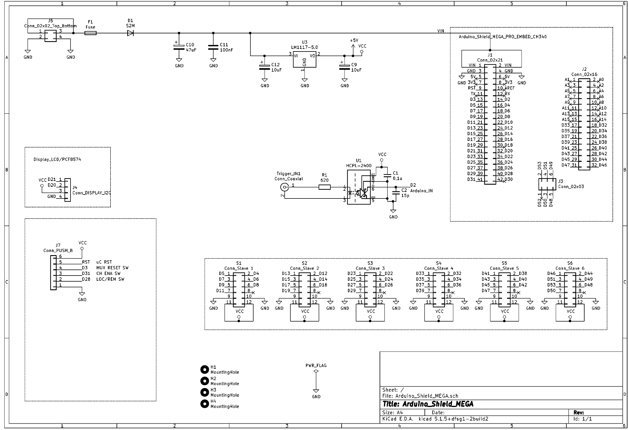

Top:



Bottom:



# Annex 7. Push buttons board

|  |  |  |  |
| --- | --- | --- | --- |
| **Item** | **Package** | **Designation** | **Vendor** |
| SW4 | SW_PUSH-12mm | SW_uC_RST | E-Switch – TL1100F160Q6JBLK – Square |
| SW3 | SW_PUSH-12mm | SW_LOC_REM | E-Switch – TL1100F160Q6JBLK – Square |
| SW2 | SW_PUSH-12mm | SW_CH_ENA | E-Switch – TL1100F160Q6JBLK – Square |
| SW1 | SW_PUSH-12mm | SW_MUX_RST | E-Switch – TL1100F160Q6JBLK – Square |
| H5,H4,H3,H2,H1 | MountingHole_2.2mm_M2 | Board Standoff | Würth Elektronik – 971150244 |
| R4 | R_1206_3216Metric | 10k | Panasonic – ERJP08F1002V |
| R3,R2,R1 | R_0805_2012Metric | 1k | Panasonic – ERJP06F1001V |
| J1 | PinHeader_1x06_P2.54mm_Horizontal | Conn_01x06 | Sullins Connector Solutions -PEC06SBAN |
| D1 | D_SOD-123 | 1N4148 or Similar | Vishay Semiconductor Diodes Division – 1N4148W-HE3-08 |
| C4 | C_0805_2012Metric | 22pF | KEMET - C0805C220J5GACTU |
| C3,C2,C1 | C_0805_2012Metric | 47nF | KEMET – C0805C473K5RACTU |



Top:



Bottom:



# Annex 8. SPDT Slave board

|  |  |  |  |
| --- | --- | --- | --- |
| **Item** | **Package** | **Designation** | **Vendor** |
| R27,R36,R35,  R34,R33,R32,  R31,R30,R29,  R25,R22,R21,  R18,R17,R14,  R13,R10,R9,  R6,R5,R2,R1 | R_0805_2012Metric | 20 | Panasonic – ERJP06F20R0V |
| R28,R26,R24,  R23,R20,R19,  R16,R15,R12,  R11,R8,R7,R4,  R3 | R_0805_2012Metric | 390 | Panasonic – ERJP06F3900V |
| C14,C12,C13,  C11,C10,C9,  C8,C7,C6,C5,  C4,C3,C2,C1 | C_1206_3216Metric | 1uF | KEMET – C1206C105K4RACTU |
| U17,U2,U1 | SOIC-20W_7.5x12.8mm_P1.27mm | *74LS244ADW* | TI – SN74LS244DW |
| C26,C24,C23 | C_0805_2012Metric | 100nF | KEMET – C0805C104K4RACTU |
| C22,C21,C20,  C19,C18,C17,  C16,C15 | C_0805_2012Metric | 1uF | KEMET – C0805C105J3RACTU |
| C25 | CP_Elec_5x3 | 22uF | Panasonic – EEEHB1C220R |
| U16,U15,U14,  U13,U12,U11,  U10,U9,U8,U7,  U6,U5,U4,U3 | SMD-6_W7.62mm_SMDSocket  _SmallPads | *VO14642AABTR* | VISHAY – VO14642AABTR |
| J8 | IDC-Header_2x06_P2.54mm_Vertical | Conn_02x06_  Top_Bottom | MOLEX - 90130-1112 |
| J3 | *SMA_Amphenol_132136*  *_Vertical* | Conn_CH2 | Amphenol RF – 132136 |
| J2 | *SMA_Amphenol_132136*  *_Vertical* | Conn_CH1 | Amphenol RF – 132136 |
| J1 | *SMA_Amphenol_132136*  *_Vertical* | Com_IO | Amphenol RF – 132136 |
| J11 | Pin_D1.0mm_L10.0mm | GRDo_1 | Amphenol ICC - 68000-401HLF |
| J10,J9,J7 | Pin_D1.0mm_L10.0mm | MEAS_GND |
| J6 | Pin_D1.0mm_L10.0mm | GRDo_2 |
| J5 | Pin_D1.0mm_L10.0mm | GRDi_2 |
| J4 | Pin_D1.0mm_L10.0mm | GRDi_1 |
| MK3,MK1,  MK4,MK2 | MountingHole_2.7mm | Mounting_  Hole_PAD | NA |
| TP6,TP2,TP5,  TP4,TP3,TP1 | TestPoint_Pad_D1.0mm | TestPoint | NA |
| TP7 | TestPoint_Pad_D1.0mm | VCC | NA |
| TP0 | TestPoint_Pad_D1.0mm | GNDDigital | NA |







Top:

Bottom:

